JETHU  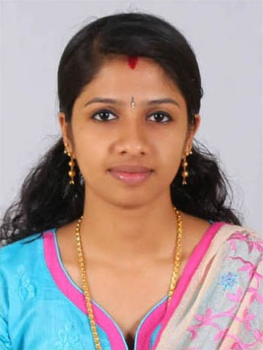  Email:  JETHU.361532@2freemail.com  Personal Profile:  Gender:  Female  Date of Birth:  27th July 1993  Nationality:  Indian  Passport no:  Date of Expiry:  25/09/2026  Visa Status:  Visit Visa  Languages Known:  English, Hindi  Malayalam and Tamil | CURRICULAM VITAE  Objective  - To contribute a reputed organization offering excellent working environment.  Work Experience  - Hi-tech Diagnostic Centre, Cochin, Kerala, India  - Over 1 year’s data entry and administrative experience  - Typing Speed 60WPM  - Highly skilled in operating a variety of office machines and equipment such as computer, fax, scanner and copier  - In-depth knowledge of MS Office applications (Word, Outlook, PowerPoint and Excel)  - Proven record of using honesty and discretion when handling business information  - Demonstrated ability to use office equipment with a high degree of accuracy and efficiency  Academic Profile  Name of Course Name of Institution / College Board /University Year  Diploma in computer application V-Tech computer education center Kozhencherry, India Board of examination of bharat sevak samaj information technology mission 2015  Diploma in Computer Engineering Govt. Polytechnic College, Vennikulam India Govt. of kerala department of technical education 2014  Plus Two SNDP HSS Karamvely, India Higher Secondary Examination 2011  SSLC SNDP HS Edappariyaram, India Board of Public Examination 2009  Computer Proficiency  Diploma in computer application (DCA) Microsoft Word, Excel, Power Point, Photoshop, C, PHP, HTML & Internet  Declaration  Would be very much pleased to attend the preliminary interview as I am confident that my qualification and experience will meet your Requirement for the job criteria. The above information is true to the best of my knowledge and belief.  Sharjah  (Jethu)

