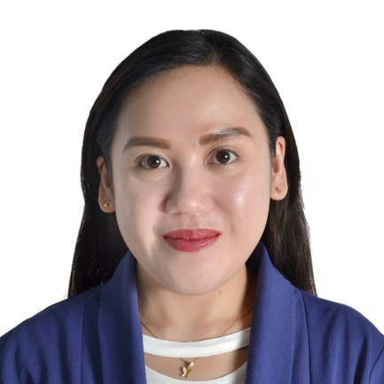

RUBY
RUBY.361534@2freemail.com

GENERAL OR SPECIALTY PRACTICE
ORAL SURGERY, PERIODONTICS, ENDODONTICS, ORTHODONTICS

CAREER PROFILE
Dental assistant with a 5+ years of experience providing efficient and competent service in a busy dental clinic.Able to handle all necessary assistant duties. Possess a DHA Eligibility Letter for the title of Dental Assistant Dental Allied Healthcare.

OBJECTIVE
Seeking a challenging opportunity within a respectable organization and to work with a group of professionals, specialty to gain more experience and build extra knowledge that allow me to serve my employer in an excellent manner and contribute greatly to achieving the hospital objectives
EDUCATIONAL QUALIFICATIONS
Bachelor of Science in Nursing
Capitol University, Cagayan de Oro City
Graduated 2008

WORK EXPERIENCES
NOOR AL-MADAR DENTAL CLINIC
Staff Nurse/General Nurse
Al-Qatif, Dammam, Saudi Arabia
February 5, 2012 – April 6, 2017

- Assists dentist in providing dental care to patients in procedures like filling, extractions and performing root canal treatments.
- Prepare patients for procedures ; ensure comfort and develop trust ; calm distressed patients; instructs patients in postoperative and general oral health care
- Oversee cleanliness of operatories and instruments; ensure safety/sanitary conditions using autoclave
- Produce dental materials to dentist in an effective and timely manner
- Provides guidance to patients on how to improve at-home dental care to prevent caries

PUERTO COMMUNITY HOSPITAL
PUERTO, Cagayan de Oro City
Staff Nurse
October 1, 2008 – December 30, 2011

- Provides professional nursing care in accordance with physician’s orders. Nursing is defined as the protection and promotion of health; the prevention of illness and injury; alleviation of suffering and advocacy in the care of individuals and communities.

PROFESSIONAL ATTAINMENT

- DHA Dubai Health Authority Licensing Exam Passer
Specialty: Dental Assistant
April 8, 2017
Eligibility Letter Issued
- Certificate of Cardiopulmonary Resuscitation as BLS Provider
Saudi Heart Association
November 24, 2016
- Professional Accreditation Certificate
Saudi Commission for Health Specialties
Registration No.
- Professional Regulation Commission
Philippines Nursing Licensure Examination Passer/ Licensed

PROFESSIONAL STRENGTH

- Knowledge of various dental equipment
- Pleasant personality and ability to communicate effectively
- Good sense of hygiene with multitasking skills
- Effective organization and time management skills
- Knowledge of assisting dentist in performing dental procedures
- Good knowledge of computer and ability to perform tasks in a professional manner

