SHEKH

SHEKH.361556@2freemail.com 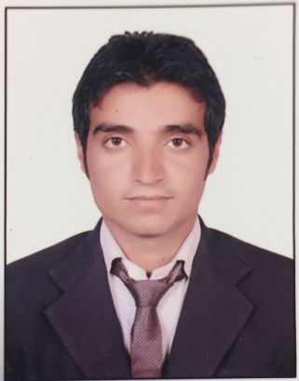

Desired Position: Accountant/account Receivable

CAREER OBJECTIVE:
To employ my knowledge and experience with the intention of securing a professional career with opportunity for challenges and career advancement, while gaining knowledge of new skills and expertise.

PERSONAL SUMMARY:

An adaptable, lateral thinker and quick learner who has extensive knowledge of general Accounting Accounts receivable procedures and general accounting processes .

CAREER HISTORY :
Experience:-  Date | Position : | Company :
2014 SEP- TILL DATE | Accountant | AAL MIR TRADING CO. LLC.
2012FEB-2014 SEP | Accounts Assistant | S.K. KUMAR & CO (Chartered)(India)

- Duties & Responsibilities:
• Responsible for supporting the accounting operations by processing invoices, daily sales, receivable and resolving queries.
• Posting daily cash receipts, “PDCR” and bank deposit in computer system.
• Deposit “PDCR’’ into bank on maturity date and update in system once credited in account.
•Update customers account after receive payment.
• Preparing bank reconciliations enter company reconciliations every month.
• Preparing bank reconciliations enter company reconciliations every month.
•Collect cash, cheques, bank deposit from van sales and settled customer accounts.
• Settle customer rent & rebate as per agreements.
• Preparing bank reconciliations enter company reconciliations every month.
• Preparing customer reconciliations as required or requested by customer.
•kept track of pending payment and collected the same through constant follow ups.
•updated billing system for payment received, payment pending and goods shipped.
•Posting payments to customer accounts and posting acknowledgement for the same.
• Provide monthly statement of accounts to customers and salesman.
•Posting monthly fuel expenses “ADNOC, EPPCO & SHELL OMAN”

WORKING WITH NESTLE:-

• Handling purchases process of Nestle.
• Handling complete accounting process (receivable, payable, customer account settlement, provide account statement.
• Follow up the payment.

ACADEMIC QUALIFICATIONS :

- Master’s Degree (M.com)

- Bachelor’s Degree (B.com)

Personal Details:

Name : Shekh
Sex : Male

Date of Birth : 02 February 1989

Religion : Muslim

Marital Status : Single

Nationality : Indian

