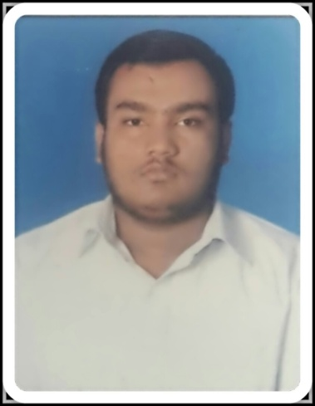
ABDUL
Abdul.361563@2freemail.com

CAREER OBJECTIVES

To pursue a long-term career in an organization with strong background, where my skills and experience work along with my caliber enhancement and skill development to let my company identify me as the best and to have a growth oriented and challenging career, where I can contribute my knowledge and skills to the organization and enhance my experience through continuous learning and teamwork.

ACCADMIC QUALIFICATION

Course | University Name | Institution Name | Year Of Passing | Percentage  /CGPA
B.E (MECHANICAL ENGINEERING) | VESVESHWARAIYA  UNIVERSITY  BELGUM | POOJYA DODDAPPA APPA COLLEGE OF ENGG GULBARGA | 2015-2016 | 79.9%
DIPLOMA  (MECH ENGG) | DEPT.OF TECHNICAL EDUCATION BANGALORE | H.K.E BOYS POLYTECHIC GULBARGA | 2012-2013 | 76.5%
SSLC | K.S.E.E.B | NOBLE HIGH SCHOOL GULBARGA | 2009-2010 | 63.36%

WORK EXPERIENCE
HH
WORKED THREE MONTHS AT ONGC (HEERA PROCESS COMPLEX) AS HELPER THROUGH SAMFIRE SERVICES

SOFTWARE PROFICIENCY

- Software known : Auto Cad, Solid edge, Lusas analyst, CNC Simulator.
  - Office suite : MS-office word, MS-Office Power point.

AREA OF INTEREST

- Oil And Gas Refinery
- Petrochemical Industry
- Manufacturing Industry
- Thermal Power Plant.

PROJECTS UNDER TAKEN

- Project Area : MANUFACTURING PROCESS
- Project Title :“Design And Fabrication Of Standup Wheel Chair”
- Project Role : Team Leader
- Software Used For Designing : Solid Edge V19

- Project Area : THERMODYNAMICS
- Project Title : “water dispenser cum refrigerator”
- Project Role : Team Leader.

INDUSTRIAL VISIT

- K.S.R.T.C WORK SHOP, HUBLI
- ALSTOM PRIVATE LTD, SHAHABAD
- JINDAL STEEL WORKS, BELLARY
- TILLARI HYDRO POWER PLANT,KODALI, MAHARASHTRA

TRAINING AND WORKSHOP UNDERGONE

Implant training:
  - TRAINING CENTER : HKES – Bosch Rexroth center H.K.E polytechnic Gulbarga
  - Duration : 5 Days
  - Knowledge Gained : Basic, Electro Hydraulics & Pneumatics
PERSONAL SKILLS

    - Ability To Work In A Team
    - Good Communication Skills
    - Co-Operative And Keen Observer
    - Grasp Things Fast
    - Problem solving ability
    - Creative and logical
    - Ability to rapidly build relationship and set up trust.

HOBBIES

- Watching TV especially NAT GEO, DISCOVERY,HISTORY TV 18.
- Playing Cricket And Carom
- Travelling.

