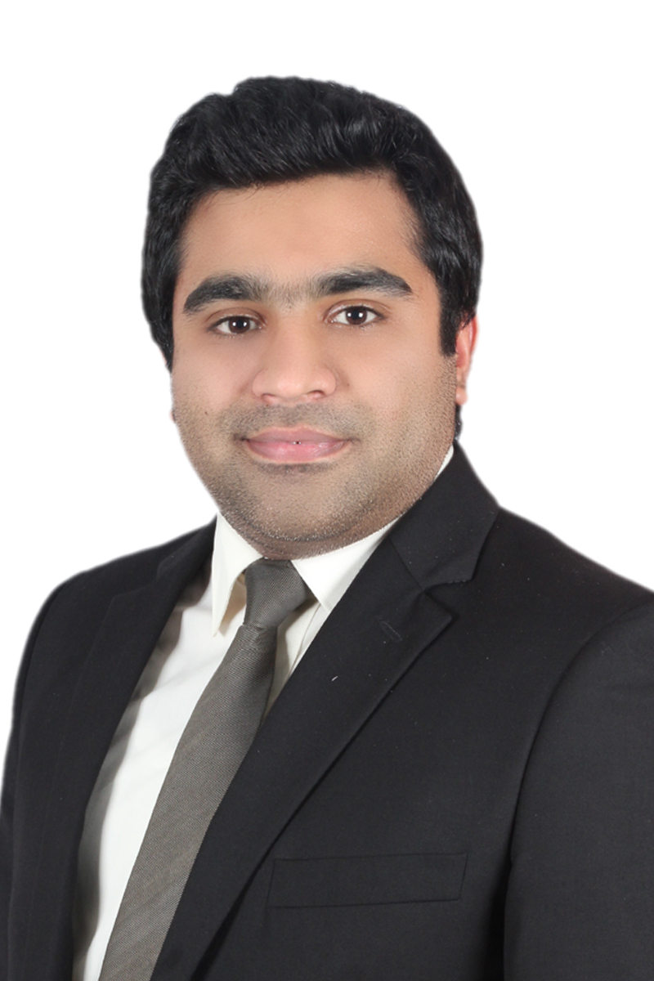

Bilal
Audit, Finance & Accounts Professional

Bilal.361569@2freemail.com

July 20, 1990
Why Bilal?
- Diligent, self-directed and committed audit finance and accounts professional possessing extensive auditing experience and expertise. Perceptive and ingenious professional with remarkable success in implementing effective auditing procedures and scheduling of audit assurance and non-assurance engagements and directing due diligence. Holds robust analytical, logical and operational skills in helping clients to achieve and maintain compliance with regulatory requirements, improve internal controls and reduce operational and financial risk. Skilled at conducting pre–implementation audits, performing relevant internal and external audits and cooperating with internal and external entities to achieve company’s objectives
- Detailed-oriented, level-headed and persistent individual, adept at conducting financial analysis of specific accounts, formulating invoices and correcting spreadsheet errors. Have astute abilities of financial decision making, business planning and operations, trends and costs while providing professional accounting and financial advice and assistance to the clients of multinational sector and management. Possesses ability to convince communicator with established management, organizational, leadership and interpersonal skills; extremely capable of managing and supervising audit teams efficaciously
- Steadfast, focused and self-disciplined specialist proficiently competent at supervising auditing of commercial and public sector organizations and determining possibility of investigation needed. Competent at multi-tasking, strategic planning, interpreting and preparing annual reports, audit payroll, financial statements and other accounting, auditing and financial reports. Extensively conversant with industry-specific software like Peachtree, Tally ERP 9, SAP FICO Financial, Oracle R12 Financials and ICT tools. Expert in preparation of financial statements and analyzation in line with the provisions of IFRS

CORE STRENGTHS & ENABLING SKILLS
- Audit and Assurance  - Internal Control and Risk Assessment  - Cost & Management Accounting  - Accounts Reconciliation | - Financial Advisory & Reporting  - Financial Statement Analysis  - Cash Flow & Risk Management  - Receivables Payables Management | - Budgeting & Variance Analysis  - IFRS/IAS/ISA  - SAP FICO Financial  - Oracle R12 Financials

House No: 1100, Block 14, Federal B Area, Karachi, Pakistan
PROFESSIONAL EXPERIENCE
KPMG Lower Gulf Limited, Abu Dhabi, UAE
Working as “Associate Audit and Assurance”, January 2017- Present
Responsibilities/Accomplishments:
- Conducting audits of financial statements, evaluating internal control system and entity’s control environment, risk management procedures, identifying flaws and proposing comprehensive audit recommendations
- Efficiently verifying financial statement captions by comparing items to documentation and perform routine trail review of audit procedures and analysis of variance reports. Reporting audit findings by preparing a final report and conferring outcomes with auditees
KPMG Taseer Hadi & Company, Lahore, Pakistan
Worked as “Audit Associate”, November 2014 - December 2016
Responsibilities/Accomplishments:
- Monitored established internal control approaches and methodology through basic assessment appraisal of records, reports, working practices and records and ensured timely completion of the audit
- Effectively prepared and documented audit deliverables including audit review reports, board letter, management letter and engagement letter; successfully built and maintained strong working relationships with clients
- Coordinated with audit team members and managerial staff presenting conclusions and recommendations, safeguarding procedures and policies; ensuring regulations are decorously conformed
Major Achievements:
- Successfully promoted to Senior Associate Audit and Assurance from Semi- Senior Associate
- Recruited to company’s Abu Dhabi Office for special assignments

Fakharuddin Yousafali & Co, Lahore, Pakistan
Worked as “Audit Associate”, May – November 2014
Responsibilities/Accomplishments:
- Investigated and evaluated accounting and financial facts of the clients, formulated financial reports and suggested appropriate assessments and estimates. Prepared and presented audit reports and statements to the top management on numerous financial aspects. Facilitated and supported audit team in their day-to-day and routine tasks and responsibilities.
- Maintained clients’ books of accounts, followed established procedures for the completion of standard documentation on audit reports, established internal control approaches and methodology through basic assessment/appraisal of records, reports, working practices and records and ensured timely completion
Packages Pvt ltd, Lahore, Pakistan
Worked as “Internee Accounts and Finance”, February - March 2013
Responsibilities/Accomplishments:
- Prepared and managed bank reconciliation statements, balance sheets reconciliation, financial statements, annual reports and accounts payables and receivables efficaciously by using accepted accounting and financial procedures
- Maintained records of physical inventory, supported payment processing team, collected spreadsheet data, performed data entry and credit checks and produced periodic summary reports
Additional Experience
- Worked on a small assignment as an Auditor at Malcus and Myre - Lahore, Pakistan (January 2013)
Helped

  - Helped

SIGNIFICANT INDUSTRIES & CLIENTS PORTFOLIO:
FMCG & Hypermarkets  - Agthia Group – Abu Dhabi, UAE  - MAF Hypermarkets Pakistan (Private) Limited  (subsidiary of Majid AL Futtaim Retail LLC UAE)  - Metro Habib Cash & Carry Private Limited, Pakistan  (subsidiary of Metro AG Germany)  - Makro Habib Pakistan Limited, Pakistan  Service Sector  - Emirates Driving Company – Abu Dhabi, UAE  - Accenture Middle East B.V. Abu Dhabi - UAE  - Albayrak Turizm Seyahat Insaat Ticaret Anonim Sirketi, Pakistan  (Branch office of Albayrak Turkey) | Manufacturing Sector  - Afri Piping Middle East Industries LLC – Dubai, UAE  - Gulf Lime Co. LLC – Abu Dhabi, UAE  - Emirates Steel Establishment – Abu Dhabi, UAE  - Gulf Steel Ind Corporation LLC – Abu Dhabi, UAE  - Star Energy Group Ltd – Abu Dhabi, UAE  - Fazal Cloth Mills Limited, Pakistan  - Fazal Weaving Mills Limited, Pakistan  - Azgard Nine Limited, Pakistan  - JDW Sugar Mills Limited, Pakistan  - Tandlianwala Sugar Mills Limited, Pakistan  - Agritech Limited, Pakistan
PROFESSIONAL QUALIFICATION

- Association of Chartered Certified Accountants, United Kingdom (December 2013)
ACCA- Affiliate
- Oxford Brookes University, Oxford, United Kingdom (2011 - 2014)
BSc. (Hons) - Applied Accounting
- Punjab University Lahore, Pakistan (2009-2010)
Bachelors of Arts
- B

Abu Dhabi

