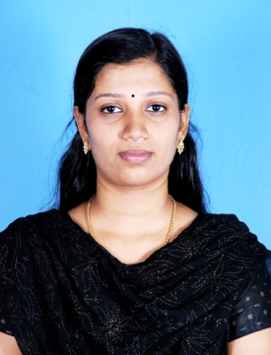

SUDHI
Electra Street, Abu Dhabi
Email: SUDHI.361570@2freemail.com

OBJECTIVE

To be a part of an organization that focuses on innovation, providing me a challenging environment and to be able to use my skills for my own career growth as well as for the welfare of the company.

PERSONAL PROFILE:

- Hardworking, dedicated and result oriented.
- Quality conscious and Good Eye on details.
- Proven capacity of time-management and organizational skills.
- Quick learner and Good Improviser.
- Ability to work towards set targets.
- Adaptability and flexibility for dynamic and changing environments.
- Team leader and Excellent inter personal skills.
- Confidence to take up responsibilities and challenge.

EDUCATIONAL QUALIFICATIONS:

Course | Institution | Board/University
DCA | SITD, Gujarat | Gujarat State Board
BSC  (Computer Science ) | Sree Narayan College | MG. University
XII | VVHS Kerala | Kerala State Board
X | Holy Angels Convent School | Gujarat State Board
BA(history) | VVM Collage of Arts, Science & Management Studies | Madurai Kamaraj University

PROGRAMING SKILLS:

- Knowledge of C, C++, MS Office, VB, Java, C, Linux OS, Mysql.
- DTP
- Accounting package, Oracle (Basic Knowledge)

SEMINARS:

- Micro TEACHING : Visual Basic, Symbian os

PROJECT:

- Online advertisement front end-asp.net, back end-mysql.

EXPERIENCE:

- LM exchange Abu Dhabi. Mussaffah. From 17 Sept 2014 to 20 Dec 2014.

- Worked as Secretary for computer operator cum Document Controller in United Electricals from 1st Jan 2013 to 31st Oct 2013.

- Worked as Asst. Accountant in Suvik Engineering from 1st July 2012 to 31st Dec 2012.

LANGUAGES KNOWN:

- English, Hindi, Malayalam, Gujarati

PERSONAL DETAILS:

- Nationality - INDIAN

- Date of Birth - 24th August 1988

- Marital Status - Married

PASSPORT DETAILS:

- Date of Issue : 25-02-2014
- Date of Expiry : 24-02-2024
- Place of Issue : Cochin
- Visa Status : Residence Visa

HOBBIES AND INTERESTS:

- Listening to music, Dancing.

STRENGTHS:

- As an individual of Strong determination I am confident that I can deliver my best to the organization, with my willingness to learn new technologies and dedication, I can prioritise work schedules, manage time effectively and meet deadlines.

DECLARATION:

I hereby declare that all the above information furnished by me is true to the best of my knowledge and belief.

Date

