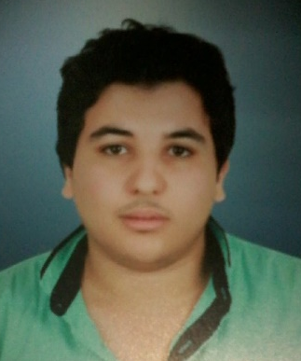
Abdelfattah
Abdelfattah.361574@2freemail.com
Architect & Designer
Notice: Location is not a problem. I can move to any workplace, so do not worry about it.

Experience
 |  | July 2013-Aug2013 |  |  | THE CENTRE OF STUDIES AND ENGINEERING CONSULTATIONS |  |  |  | Mansoura university, Eg

Summer training
- Summer training contents to show the working of Educational building.
- Participation in the supervision of receipt of the finishing works in the Faculty of Arts of the new building.

 |  | July-2014-Aug 2014 |  |  | Housing and reconstruction company |  |  |  | New Damietta, Egypt

Summer training
- I worked under summer internship in the company.
- l Learned how to design Residential building, the structure of the building, and the working.

Education | 2011-2016 |  | Mansoura university Faculty of engineering - Architecture Department |  |  |  | Mansoura, Egypt
Bachelor of Architecture
Graduation project: Cultural Heritage Center in Rosetta Degree: Good

Language
- Arabic (Native Language)
- English
- German
computer skills
AutoCAD
MS Word
MS Excel
MS PowerPoint
Revit
3D max
Adobe Photoshop

ARTCAM PRO 2008
RHINO 2D

