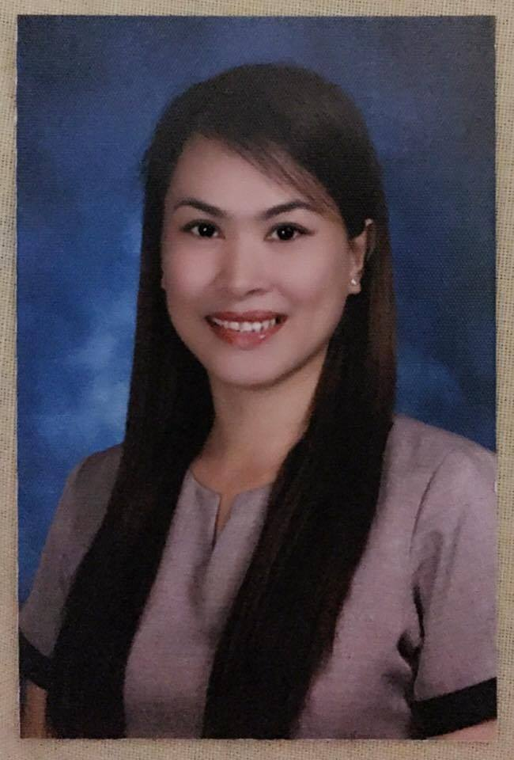
Rhodalyn
Rhodalyn.361628@2freemail.com

Vision and Objectives
Intend to get a position to utilize my skills and abilities into practice for mutual growth and development and to have cultural exposure and hands-on experience in the field of hospitality management as a gateway to a meaningful career to become more globally competitive.

Work Experience

- Myx Miniotel, Roxas Isabela, Philippines
Position: Front Desk Officer – (April 2014-January 2017)
- La Salette of Roxas College Inc. Philippines
Position: Grade School Teacher, Adviser, Choir Moderator
Subject Taught: English– (June 2015-March 2016)
Technology & Livelihood Education– (June 2015-March 2016)
- Private Tutor – (April 2014-January 2017)
- E&T Commercial, Roxas Isabela, Philippines
Position: Sales Clerk Officer/Secretary – (January 2011-April 2014)
- Sun Lady, Tokyo Japan
Position: Food Server – (December 2004-July 2010)
- Takashi Resto, Tokyo Japan
Position: Food Server – (December 2004-July 2010)

Skills/Qualifications

- A bachelor's degree graduate
- With post graduate education course
- Completed a bachelor’s education program
- Supervised teaching and customer service experience
- Professional skills in literacy and numeracy
- Computer literate: Microsoft Word, Excel, PowerPoint, Publisher

- Special Awards/Honors:
- PAPSET Medallion Recipient for the Highest Academic Award
(Philippine Association of Pre-Service Teachers, Inc.)
- Meritorious Citation Award
- Leadership Award

Qualities

- Patient, hard-working, attentive, organized, adaptable, motivated
- With clear “Communication, Inter-personal, Intra-personal Skills”
- Fast learner and can work under pressure
- Has the ability to Use “Positive Language”
- Good “Time-management Skills”
- Ability to “Read” customers

Education

Master of Arts in Education
Major in English
Our Lady of the Pillar College – Cauayan City, Philippines

Bachelor of Secondary Education
Major in English /Minor in Religious Education
University of La Salette Inc. – Santiago City, Philippines

Seminars and Trainings

- Microsoft Office Application
November 3-December 3, 2016, Roxas Isabela
- National Seminar-Workshop
Theme: “Enhancing Literacy, Creative and Public Speaking Skills of Teachers and Coaches”
January 17-19, 2015 Romulo Hall, Teachers’ Camp, Baguio City
- International Midyear Convention of the Philippine Association of Pre-Service Teachers, Inc.
Theme: “Updating Pre-service and In-service Teachers’ Pedagogical Competencies in the Core Subject Areas Anchored in the K to 12 Curriculum” – January 9-11, 2015 Our Lady of the Pillar Parish Pastoral Center, Cauayan City, Isabela
- Salettinian Young Leaders Congress and Team Building Activity
Theme: “Empowering Values and Vision of Salettinian Leaders” – July 31, 2013, University of La Salette Roxas Campus, Magsaysay St., Vira, Roxas, Isabela
- Speech Communication Organization of the Philippines, Inc. Midyear Seminar – Workshop
Theme: “Social Transformation Through Communication” – October 25-27, 2012, Hotel Veniz, Baguio City
- Classroom Management Seminar – August 18, 2012, La Salette of Roxas, Roxas, Isabela
- Salettinian Young Leaders Congress and Team Building Activity
Theme: “Transformational and Positive Leadership, Bringing Student Leaders to the Next Level”
June 30 – July 1, 2012, University La Salette – Roxas Campus, Magsaysay St., Vira, Roxas, Isabela

Personal Details:

Date of Birth: March 22, 1983
Visa Type: Long Term Visit-Tourist Nationality: Philippines
Status: Single Height: 5’5” ft.
Language: English, Filipino, basic Japanese Religion: Roman Catholic

References will be provided upon request.

I hereby certify that the above information is true and correct to the best of my knowledge and belief.

