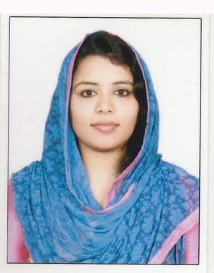
CURRICULUM VITAE

SHALIMAR
E-MAIL: SHALIMAR.361636@2freemail.com

OBJECTIVE
To seek a meaningful and challenging career in a dynamic and professionally managed organization. Looking forward for a position where responsibility is entrusted and where I can effectively contribute to the organization, and also to satisfy my passion to learn and experiment on new things and lead success through difference. To pursue a challenging career where my knowledge will be optimally utilized and grow with the organization by evolving a sense of participation and team work towards the achievements of organizational goals.
WORK EXPERIENCE
Company : M/s. LUKMANIYA AYURVEDICS, Thrissur.
Designation : “ACCOUNTANT”
Period : MARCH 2015 TO TILL DATE
Work profile
- Completing the financial report on a regular basis and providing information to the finance team
- Completing bank reconciliation
- Verifying balance in account book and rectifying discrepancies
- Verifying bank deposit
- Managing day-to-day transactions
- Handling accrual and pre-payment
- Resolving errors in financial report and correcting fault reporting method
- Entering financial information in to appropriated software
- Reporting on debtors and creditors
- Completing work order
- Posting daily receipt
- Processing business expense
- Recording office expenses and ensuring these expense are within the set budget
- Reviewing computer report for accuracy and tracing error to their source Encoding accounting entries for data processing
- Sorting financial documents and posting them to proper accounts
- Preparing financial documents such as invoices ,bills ,and accounts payables and receivables
- Managing office ledger
- Assisting seniors with audits
- Handling accounting day to day transactions.
EDUCATIONAL QUALIFICATION
MBA Financial Management | Christ College,irinjalakuda  Bharathiyar University | 2012-2014
Bachelor of Commerce | St. josephs college ,Irinjalakuda  MG University | 2008-2011
Certificate 12th Secondary School | G.V.H.S.S Thalikulam  Kerala State Board | 2006-2008
Secondary School | SCGHS Peringottukara  Kerala State Board | 2005-2006

Computer Skills : ERP 9 Tally, Microsoft Office-2010, 2013, 2017 etc.

Typing SKILLS : English with Good Speed

PERSONAL SKILLS :

- Positive attitude, self-motivation and logical thinking.
- Interpersonal and Communication skills, coupled with strong technical and problem solving capabilities.
- Ability to work independently with minimum supervision in a fast-paced environment.
- Interested in learning new technologies and mastering new skills
- Ability to work in a fast paced changing environment.
- Willingness to work flexible hours.
- Motivated and committed to excellence
- Confident and hardworking with a positive attitude.
- Good communication and interpersonal skills.
- Team player with the ability to lead
- Punctual and systematic.
INTERNSHIP PROJECTS

KSE Limited, Irinjalakuda, Thrissur on “Working Capital Management”.

LANGUAGES KNOWN:

English, Malayalam & Tamil,etc.

PERSONAL DETAILS :
Gender : Female
Date of Birth : 31st March 1991
Nationality : Indian
Marital Status : Married

PASSPORT DETAILS :

Date of Issue. : 08 / 02/ 2017
Date of Expiry : 07 / 02 / 2027
Place of Issue : Cochin

DECLARATION

I hereby declare that the above-mentioned information is correct up to my knowledge and I bear the responsibility for the correctness of above-mentioned particulars.

