**Personal skills Professional skills**

- Highly motivated and eager to learn new things. Business administration  
 - Strong motivational and leadership skills. Quick Books  
 - Ability to produce best result in pressure situation. Telly ERP 9  
 - Excellent communication skills in written and verbal SPSS & Microsoft office

Versatile and highly self-motivated accountant with 1 year of accounts experience.  Well-versed in accounting regulations standard practices and confidentiality issues.

- Expert in implementation of each step of project.  
 - Eager to learn new technologies and methodologies.

p

**Accountant**

1year working experience as a accountant in Masood Enterprises Islamabad Pakistan from 1st Jan to 30th Dec.

**Key** **Responsibilities**

Recording daily transactions, general ledger trial balance and preparing financial reports.

Inventory management, estimating cost & revenue and maintaining & analyzing budgets.

**Customer Service Representative**

10 months working experience as a CSR (Customer Service Representative) in Kareemiya Technologies & IT Solutions Rawalpindi Pakistan from 1st Jan to 25 Oct.

**Key** **Responsibilities**

Making outbound calls, convincing customers, service & product information and maintaining customer records.

Handling customer complaints and making possible customer leads and sales.

**Education**

**Personal information**

D.O.B: 01-09-1990

Nationality: Pakistani

Religion: Islam

Visa status: Visit visa till 1st of June

**Experience**

MBA with major in finance from AJK University with 77%

Bachelor of Commerce (B.Com) from AJK University with 65 %

  Summary

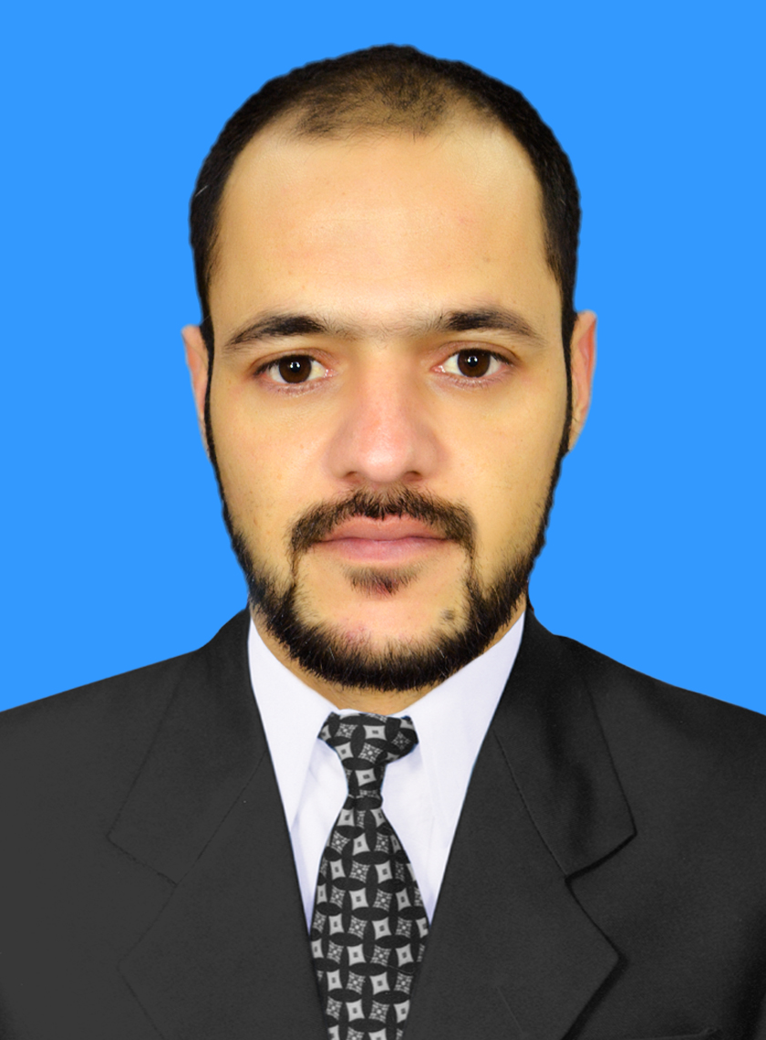

Imran

Email: [Imran.361642@2freemail.com](mailto:Imran.361642@2freemail.com)