CURRICULUM VITAE

ANSAR  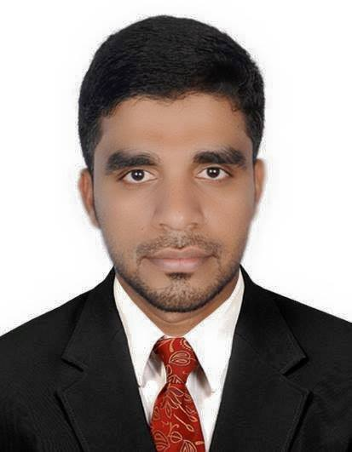  Ansar.361646@2freemail.com  Personal Profile  D.O.B: 11-05-1988  Gender: Male  Marital Status: Married  Nationality: Indian  Religion:Islam  Interest and Hobbies  - Reading  - Writing  - Traveling  - Organizing  Languages Known  English  - Speaking  - Writing  - Reading  Arabic  - Speaking  - Writing  - Reading  Malayalam  - Speaking  - Writing  - Reading  Hindi  - Speaking  - Reading | Objective  Seeking an objective for professional growth and increasing responsibility as a professional in an organization where team spirit and personal skills are recognized and rewarded.  Working Experience  - Organization : Darul Huda English School  - Designation : English Language Teacher  - Period : Nov2011-March2015  - Place : Nadapuram, Kerala  -------------------------------------------------------------------------------------------  - Organization : Darul Huda Arts And Science College (Affliated to University of Calicut)  - Designation : NSS Programme Officer  - Period : 2013-2015  - Place : Nadapuram, Kerala, India  -------------------------------------------------------------------------------------------  - Organization : Adnoc distribution  - Designation : Sales attendant  - Period : Oct- 2015 –Jun2016  - Place : Abudhabi, U AE
- Organization : Darul Huda Arts & Science College
- Designation : Facilitator in Language And Literature
- Period : August 2016 –March 2017
- Place : Nadapuram, Kerala.
Academic Record

- MA English( language and literature)- 2013
- Kerala State Eligibility Test Passed - 2013

- B.Ed. in English language-Calicut University -2011

- Bachelor of Arts(BA English, Language and Literature) -2010

- DCA, Diploma in computer application.

Achievements

- Worked as NSS (National service scheme) Programme Officer
- Was able to create and organize departments within the institution for smooth and efficient functioning.
- Guided different department heads with issues related to their departments.
- Kerala State Eligibility Test in English language was passed
- Trained the subordinates in relation management.
- Determined and recommended public relations practices necessary to establish a positive relationship and promote a high level of morale and motivation.
- Monitored and advised supervisors in the progressive discipline system of the institution.
- Reviewed public appeals through the institution complaint procedure

Synopsis

- Adopt any circumstance, flexible to learn new things, Good Interpersonal skills.

- Self-motivated, energetic & optimistic person who works as a heart of a team

- Excellent in Writing & Oral Communication, Inter Personal, and problem solving skills with the ability to work in multi-cultural environment.

Declaration

I hereby declare that the information furnished above is true to the best of my knowledge

