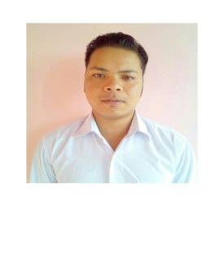
RESUME
Barnabas
Barnabas.361651@2freemail.com
Career Objective-
To make my career in hotel management field by using my good management skills for the mutual growth.
Educational Background-
Passed higher secondary from MBOSE board in year 2012 with 70.03 %.
Passed secondary school from MBOSE board in year 2010 with 80.3 %.
Additional Qualification-
Ms word, excel and powerpoint (Beginner)
Training undertaken-
3 months hospitality training from Don Bosco Technical School Shillong.
Learning include-
houesekeeping ,f&b services,front office.
-Observing the team handling by supervisor
-To solve the customers problem.
-Understanding the administration activities.
Work Experience-
1 year experience as a front office staff at Sagara Beach Resort Kovalam kerala india.
Key skills-
-Good listening skills.
-Team management.
-Good leadership skills.
-Good motivator.
-Hard working.
-Disciplined.
Hobbies-
-Playing athlete games.
-Swimming
-Watching TV.
DECLARATION-
I hereby declare that the details furnished above are true and correct to the best of my knowledge and belief and I undertake to inform you of any changes therein, immediately.

