RESUME

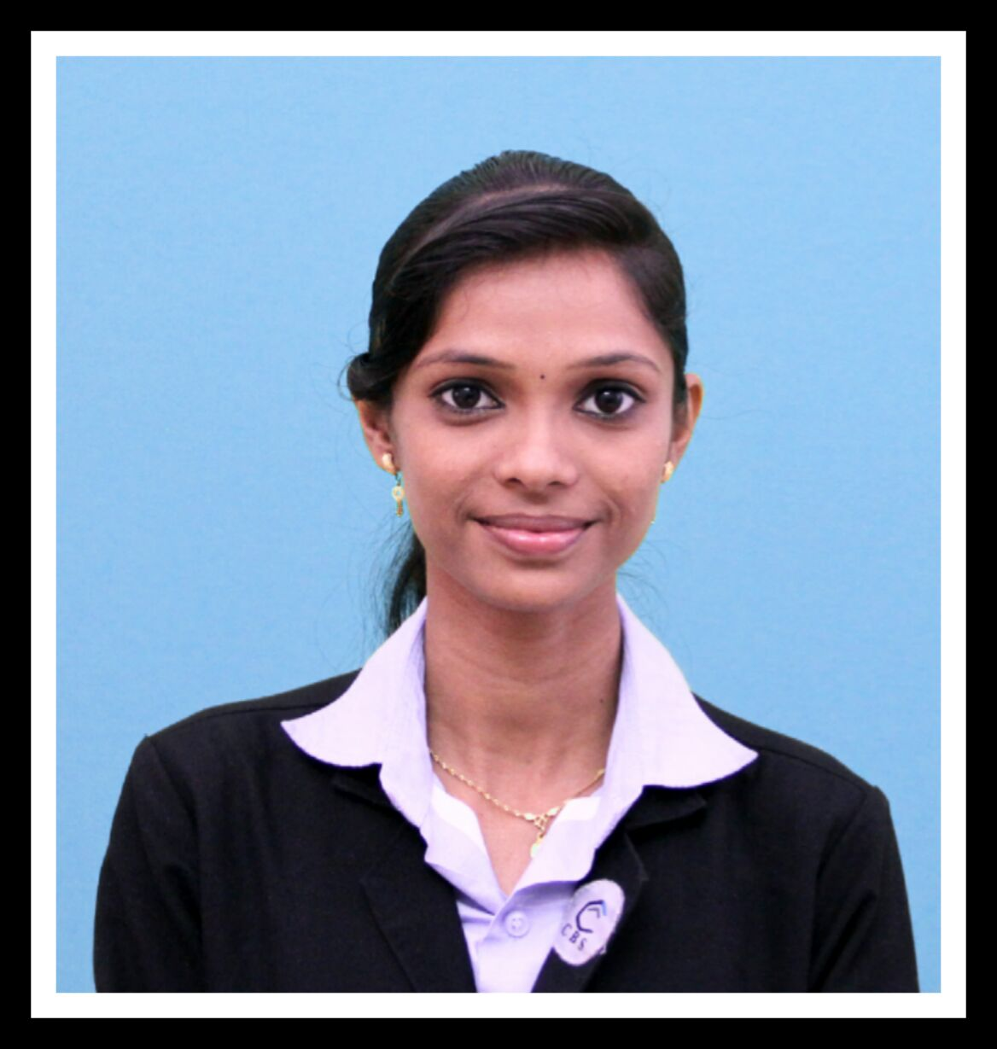
VRINDA
Email: VRINDA.361713@2freemail.com

CAREER OBJECTIVE
To seek challenging avenues where my knowledge, experience and creativity matches with the organization's growth and development.

EDUCATIONAL QUALIFICATION
Year | Qualification | University | Subject | % of marks
2015-2017 | MBA | Calicut University | HR & International Business | Result awaited
2015-2017 | M.COM (SDE) | Bharathiar University | Finance | Result awaited
2012-2015 | B.COM | Calicut University | Finance | 65%
2010-2012 | +2 | VHSE | Commerce | 70%
2010 | 10 | Kerala state syllabus | - | 70%

MBA SPECIALIZATIONS
- Human Resource Management
- International Business
M.COM SPECIALIZATION
- Finance

PROJECT WORKDONE
MBA PROJECT
- A study on effectiveness of channel/distribution strategies of Mahendra Pumps in international markets at Mahendra Pumps pvt ltd, Coimbatore, Tamilnadu, India

- A study on effectiveness of welfare measures and its impact on employee motivation at Apollo Tyres, Kalamasseri, Eranamkulam, Kerala, India

B.COM PROJECT
- A Study on the Effectiveness of employee reward and their performance at SIMCO pvt ltd Kulappulli, Palakkad, Kerala, India

TRAININGS UNDERGONE
- Internship attended at Mahendra Pumps pvt ltd, Coimbatore, Tamilnadu
- On the Job trainings at Big Bazar, Palakkad, Kerala
- Business correspondent and Business facilitator training under the guidance of Edubridge Learning private limited, Certificate provided by National Skill Development Corporation.
- On the Job training at Pattambi Co Operative Bank, Palakkad, Kerala
- National Service Scheme leadership training

COMPUTER KNOWLEDGE
- M.S Office
- Tally

OTHER KNOWLEDGE

- Type writing lower and higher

SKILLS IN THE RESPECTIVE FIELD
- Leadership Skill
- Learning Skill
- Managing skill

STRENGTHS
- Flexible
- Bold
- Confident
- Adaptive

EXPERIENCE
6 Years anchoring experience in Asianet Cable Vision channel, Pattambi, Kerala

PERSONAL DETAILS
Age : 22
Date of Birth : 05/10/1994
Marital Status : Single
Nationality : Indian

DECLARATION
I hereby declare that above mentioned details are truth in my knowledge and belief.

Date: 25.02.2017 Signature

