                - CURRICULUM VITAE
B.Com, PGDBA WITH 28 YEARS EXPERIENCE (INDIA AND ABROAD)
IN ACCOUNTS, ADMIN, HR, BUSINESS OUTSOURCING

                - Mohammed
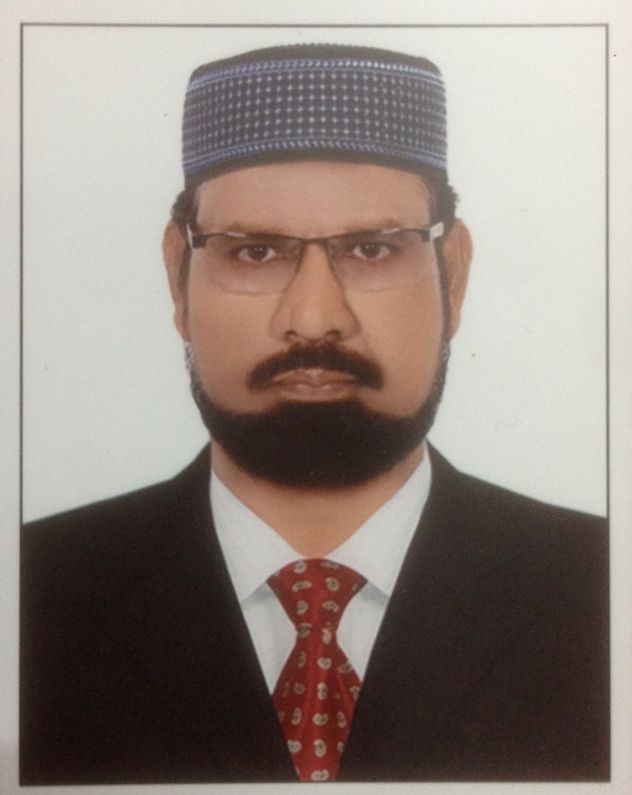
                - Mohammed.361730@2freemail.com

HAVING VALID UAE CAR DRIVING LICENSE

Post applied for : Accounts / Admin / Hr / Stores or suitable position

OBJECTIVE:

Seeking a position to utilize my skills and experience for the development of the concern and for myself where I join.
                - Professional Experience: 28 Years
Organisation : KPS FOODSTUFF TRADING LLC, Dubai (Temporary Vacancy)
Duration : Nov, 2016 to Jan, 2017
Position : Accounts Manager
Responsibilities : Accounts upto finalization, reporting to MD

Organization: ASR Group of companies
Duration: 30.12.2015 to 19.10.2016
Position: Accounts Manager
Responsibilities: Responsible for smooth functioning a/c dept, reporting to GM and Chairman
FROM MAY, 2012 TO NOV, 2015 WORKED WITH FARMLAND GROUP

Organization: | M/s. Horizon Aluminium & Steel Works (LLC), Umm Al Quwain, UAE  (FARMLAND GROUP)
Duration: | Jun-15 to Nov-15
Position: | Divisional Manager
Responsibilities: | - Direct marketing  - Meeting Contractors and Consultants to get business  - Procuring funds for business  - Planning for procurement of materials  - Organising manpower  - Liasion with government depts.

Organization: | M/s. Dar Al Irtifa Tech. Cont. (LLC), Sharjah, UAE  (FARMLAND GROUP)
Duration: | Jan-15 to Jun-15
Position: | Manager – Business Development
Responsibilities: | - Direct marketing  - Meeting Contractors and Consultants to get business  - Submission and follow-up of quotations  - Submission of bills & follow-up of payments

Organization: | M/s. Farmland Food Products (LLC), Dubai, UAE  (FARMLAND GROUP)
Duration: | May-12 to Dec-14
Position: | Admin/HR Manager
Responsibilities: | - Review of Debtors control account  - Direct visit to debtors to recover overdue payments  - Filing police case against cheque bouncing  - Legal action and filing court cases against defaulters  - Analyse manpower requirement  - Recruiting employees  - Employee performance & increments  - Verifying employee data records  - Approval of employee annual leave & benefits  - Co-ordinating with Municipality Authorities  - Organising training for food handlers  - Conducting meeting with sales team to review of payments

Organization: | M/s. A Victory Home, Chennai, India
Duration: | Jan-11 to Apr-12
Position: | Accounts Manager
Responsibilities: | - Monitoring day to day transactions  - Review of debtors control account  - Review of creditors control account  - Checking vouchers  - Liaison with banking operations  - Approval of quotations  - EMI control statements  - Control and tracking of PDCs  - Guiding subordinates  - Conducting meeting with sales team to review of payments

Organization: | M/s Sirohia & Co., (Chartered Accountants), Chennai, India
Duration: | Apr-09 to Jan-11
Position: | Senior Accounts Executive
Responsibilities: | - Finalization and Audit of various clients accounts.

Organization: | M/s. M-Three Solutions LLC., Dubai, UAE
Duration: | Feb-08 to Feb-09
Position: | Accounts Executive
Responsibilities: | - Finalization of Accounts (Trial Balance, P&L A/C & Balance Sheet)  - Accounting Transactions  - Bank Reconciliation and review thereon  - Debtor’s Ledger review and age-wise analysis of debtors and communication with debtors for collection  - Reconciliation of Debtors account and review thereon  - Reconciliation of Creditors account and review thereon  - Generation of MIS Reports  - Internal Audit

Organization: | M/s. Southern Motor Cycles, Chennai, India
Duration: | Jul-97 to Nov-07
Position: | Accounts Manager
Responsibilities: | - Accounting transactions  - Bank reconciliation and review thereon  - Stock statement to Hero Honda Motors Ltd  - Debtor’s statement reconciliation and review of debtors & creditors control accounts  - Monthly Sales tax, Vat returns  - TDS &FBT  - Preparing statements for Sales Tax Assessment and hearing  - Finalization of Accounts (Trial Balance, P & L, Balance Sheet)

Organization: | M/s. Anaikar Leather Industries Pvt. Ltd., Chennai, India
Duration: | Jun-96 to Jul-97
Position: | Executive
Responsibilities: | - Carried out banks works  - Negotiation of export documents  - Follow-up of remittances from overseas buyers  - Follow-up of imports
Organization: | M/s. Arab Desert LLC, Muscat, Sultanate of Oman
Duration: | Mar-94 to Apr-96
Position: | Assistant Accountant/Sales Executive
Responsibilities: | - Updating all registers, Day book and Ledgers  - Liaison with banks  - Reconciliation of bank statements  - Reconciliation of debtors and creditors statements  - Customer relationship  - Follow-up of orders and Collections  - Co-coordinating with Sales managers
Organization: | M/s. Brown Leather Co., Chennai, India
Duration: | Nov-88 to Mar-94
Position: | Accountant
Responsibilities: | - Updating registers, Day book and Ledgers  - Liaison with bank works  - Export documentation  - Follow-up of receivables  - Preparing cheques to suppliers
                - ACADEMIC DETAILS:
- Post Graduate Diploma in Business Administration
- Bachelor of Commerce
                - SKILLS AND CERTIFICATION:
- Diploma in Computer Programming & PC Application
- Accounting packages : Tally 9.0 and ACE.
Typewriting
                - PERSONAL PROFILE:
- Date of Birth :15th Feb 1961
- Sex : Male
- Marital Status : Married
- Languages Known : English, Hindi, Urdu, Telugu and Tamil
- Nationality : Indian

I hereby declare that the above furnished information is true to the best of my knowledge and belief

