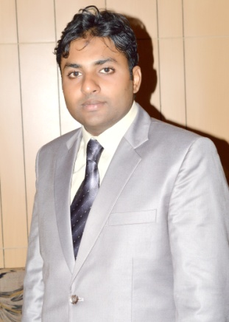  ADEEL  EMAIL  Adeel.361770@2freemail.com  GENDER  Male  DATE OF BIRTH  06- Jan -1990  NATIONALITY  Pakistani  Driving licence  Yes  Marital Status  Single  ADEEL | CIVIL ENGINEER  CAREER SUMMARY  Seeking the position of civil engineer with an established construction firm where I can explore my knowledge and skills while working towards civil engineering projects. To contribute to the success of projects using my skills in project management, site surveys and structural engineering.  EDUCATION  Bachelor of Science in Civil Technology Engineering  With 2.94 CGPA  (Aug 2010-Mar 2014) The University of Lahore  High School Certificate, DAE CIVIL (AUG2006-JUN2009)  (Govt. Polytechnicaly Institute Sialkot)  PUNJAB BOARD OF TECHNICAL EDUCATION  Matriculation,(JUN2006)  (Private of Science Klasswala )  Gujranwala Education Board  PROFESSIONAL EXPERIENCE  NASIR SALAH AL-HAMMAD (HAIL).(SAUDI ARABIA)  (CIVIL Engineer)  From 01 nov 2016 to Present  Project  - To Construct MULT-STORY BUILDING  - Residency Buildings  Duties and Responsibilities  - Working on the most innovative technology of the century “Ultra High Performance Concrete”.  - Design and Analysis of buildings manufacture with “Ultra High Performance Concrete”.  - The engineer needs to firstly prepare the blueprints of the most functional and cost effective design.  - Responsible for estimating the entire building project or a part of the building as required.  - It is necessary to make the effective communication with the contractors regarding the construction work.  - Following the orders of the chief engineer and works under the supervision.  - It will be the responsibility to ensure the safety standards of the building and the design is strong and durable.  - Responsible for ensuring the government standards in the design, including materials used and structural elements.  - It is needed to generate the three-dimensional computer models to test the efficiency.  - Responsible for the preparation of the construction schedule depending on his or her position in the project.  - It is also needed to visit the construction site timely and may have to shift place of residence during construction phase and other situations.  PROVINCIAL PUNJAB HIGHWAY DEPTARTMENT GUJRANWALA (PAKISTAN)  (Civil Engineer)  From AUG 2015 To Aug 2016  Project: Flyover at Aziz Cross G.T Gujranwala  Duties and Responsibilities  - The prime responsibility is to do the survey of the site of construction to access the suitability.  - It is needed to design the various bridge components by keeping all the factors in the mind such as keeping with expected soil strength.  - Design and Analysis of bridge manufacture with “Ultra High Performance Concrete”.  - Responsible for estimating the entire bridge project or a part of the bridge as required.  - It is necessary to make the effective communication with the contractors regarding the construction work.  - Following the orders of the chief engineer and works under the supervision.  - It will be the responsibility to ensure the safety standards of the building and the design is strong and durable.  - Responsible for ensuring the government standards in the design, including materials used and structural elements.  Abdul Razzak Associates (Pvt) Ltd.(Pakistan)  (Civil Engineer)  From 01Jan 2011 to march 2014  Project: To construct 25 multi-StoryGold crest Shopping mall and residency building at DD-Block DHA phase 4 Lahore, Pakistan.  Duties and Responsibilities  - Checking of Layout and levels according to the drawing.  - Execution ,monitoring and controlling Of Piling  - Monitoring of Post tensioning of concrete blocks for preventing soil settlement.  - Raft Preparation and casting.  - Preparation and casting of all beam and columns according to the drawing and specified by the consultant.  - Retaining walls Construction  - Quantity Estimation  - Supervise the work of sub-contractors and work closely with other site operations staff to meet the project schedule.  - Following all the rules and regulation, requirement of clients and instruction from consultant and architect.  Internship & Projects  - Final Year Project on Dam  Final Year (Duration 1 Year)  University Of Lahore, Pakistan.  - Case Study of NeelumJehlum Hydro Power Project and its conflicts with Kishan Ganga Dam.  COMPUTER SKILLS  - Microsoft Office  - Microsoft Project  - Primavera P6  LANGUAGES  Read Write Speak  English Excellent Excellent Excellent  Urdu/Hindi Excellent Excellent Excellent  SAUDI ARABIA - - Entry Level  REFERENCE  - Will be provided on demand.

