Maneesha
Maneesha.361771@2freemail.com
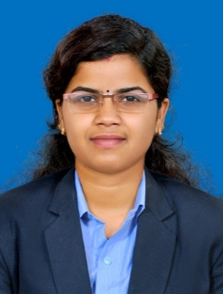

OBJECTIVE
I am looking for a challenging jobwherei can enhance my skill and knowledge.
I want to learn from the organization and growth with organization.
To exhibit my knowledge, deliver my potential effectively and efficiently.
To learn and use the skillsets, to enhance the productivity which determines me distinctively.
INTERNSHIP
LARSEN&TOUBRO Construction, Building &Factories Independent Company
- 2 months of work experience in L&T Construction, Building &Factories Independent Company
- Company Profile: L&T Construction, Building &Factories Independent Company
- Job Profile: Conducting DESI Training program me for L&T site staffs
- Project Title: A Study on Site Based TrainingProgram m
Strengths
- Keen to learn new skills
- Positive Attitude
- Communication to Responsibilities
- I am self motivated and hard working girl with positive attitude towards
My career and life
Weakness
- Straightforward
- Sensitive
MILE STONES IN EDUCATION

- 2015 MBA(Master of Business Administration)
Chinmaya Institute of Management& Technology
Passed with First Class
Now I am doing M.com (Master of Commerce)
- 2013 B.com(Bachelor Of Commerce) Chinmaya Institute of Management& Technology)
Passed with First class
- +2(Commerce)
Govt. Higher Secondary School, Shornur Passed with First class

COMPUTER SKILLS
DCA (Diploma in Computer Application)
Accounting Package: Tally
Operating System: Windows 7&8, Xp

