361801@gulfjobseekers.com

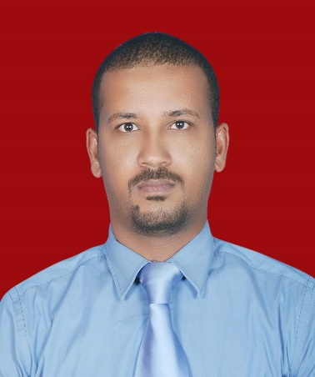

Objective: To be a part of an organization that pioneers in patient care and treatment, that fosters growth, performance, learning and rewards achievements.
Summary:
- A Medical professional with about 12 years of experience in reputed Hospitals.
- Well experienced as a General Practitioner and ER Practitioner with Gulf experience.
- Manage critically ill Cardiac patients – Myocardial Infarction, Heart Failure, Arrhythmia.
- BLS and ACLS Certified by American Heart Association.
- Licensed with Health Authority of Abu Dhabi, UAE.
- Member of royal college of physicians MRCP(UK)

EDUCATION:

MRCP(UK)

MBBS

- ROYAL COLLEGE OF PHYSICIANS (LONDON)

- UNIVERSITY OF GEZIRA-FACULTY OF MEDICINE

EXPERIENCE:

JULY 2013 – To Present |  | ADNOC (Abu Dhabi National Oil Company), Abu Dhabi, U.A.E. | Physician
Organization | ADNOC Medical Center is a dedicated high class medical center for employees of ADNOC group of companies.
Responsibilities:
As a General Practitioner and ER GP.
Attending and treating regular OPD patients, sending required investigations. Attending the Emergency patients in the ER and giving them necessary treatments.
Referring complicated cases beyond the scope of the clinic to specialized higher medical centers / hospitals.

OCTOBER 2008 –  31/may 2013 |  | AMBLATORY HEALTH SERVICE(AHS) ABU Dhabi U.A.E. (A JCSI Accredited health centers) | General Practitioner
Organization | Ambulatory health service is one of the leading governmental primary health care in Abu Dhabi.
Responsibilities:
As a General Practitioner and ER GP.
Attending and treating regular OPD patients, sending required investigations. Attending the Emergency patients in the ER and giving them necessary treatments. Referring complicated cases to the Specialist/ Consultant.
Performing pre-employment and periodic routine medical checkup of the employees of various establishments.

DECEMBER 2005 –  MARCH 2008 |  | YASTABSHIROON MEDICAL CENTER,  SUDAN-KHARTOUM | General Practitioner
Organization | Yastabshiroon medical center one of the largest centers in Khartoum
Responsibilities:
As a General Practitioner/ Family Medicine physician and ER GP.
Attending and treating regular OPD patients, sending required investigations. Attending the Emergency patients in the ER and giving them necessary treatments. Referring complicated cases to the Specialist/ Consultant.

22/6/2004-26/11/2005 |  | INTERNSHIP |  | House Officer
22/6/2004-22/9/2004 |  | OMDURMAN MILITARY TEACHING HOSPITAL | OBS & GYNA
26/9/2004-26/11/2004 |  | ALRIBAT TEACHING HOSPITAL | ORTHOPAEDICS
14/12/2004-14/3/2005 |  | KHARTOUM TEACHING HOSPITAL | Pediatrics.
23/3/2005-23/6/2005 |  | ACADEMY TEACHING Hospital | Medicine.
25/6/2005 –  25/9/2005 |  | ALRIBAT TEACHING HOSPITAL | Surgery
26/9/2005-26/11/2005 |  | ALRIBAT TEACHING HOSPITAL | Pediatrics

Certifications:

Membership Of Royal College Of Physicians (London) MRCP (UK)
- Licensed with Health Authority of Abu Dhabi (HAAD), UAE.
- American Heart Association – BLS & ACLS Certified.
- Registered with Sudanese medical council.

- Languages known:
- ARABIC & ENGLISH

Hobbies & Interests:
- Reading scientific journals
- Football & tennis

Personal Details:

Date of Birth | 7th^{h} January 1980
Marital Status | Married
Driving Licenses | UAE & SUDAN.

