CURRICULUM VITAE
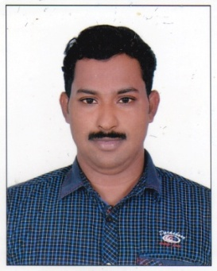
YOUSAF
YOUSAF.361803@2freemail.com

OBJECTIVE
To procure a challenging position in an innovative and progressive company where my skills and abilities can be utilized for my professional growth, the company's benefit as well as to serve the whole of mankind.
WORKING EXPERIENCE
- 1 Year working experience as a Cook at Sheik Palace in Oman.
- 4 Years working experience as an Arabic Cook with H.H. SHAIK ABDULLA, S PALACE in Abu Dhabi.
- 4 Years working experience as an Arabic Cook with ARMED FORCE OFFICER CLUB & HOTEL in Abu Dhabi – UAE.
EDUCATIONAL QUALIFICATION

- SSLC
PASSPORT DETAILS
Date of Issue : 03-01-2012
Date of Expiry : 02-01-2022
Place of Issue : Abu Dhabi
PERSONAL DETAILS
Date of Birth : 02/02/1983
Religion & Caste : Muslim
Sex : Male
Nationality : Indian
Marital Status : Married
Language Known : English, Malayalam, Hindi & Arabic
Declaration
I hereby declare that the above mentioned details are true and relevant to the best of my knowledge and belief
Place: Koolimuttam
Date:

