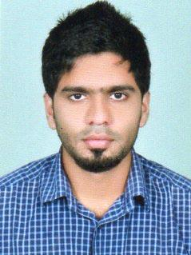
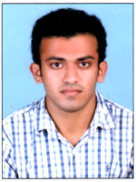
CV OF ACCOUNTANT

MUHAMMED
MUHAMMED.361843@2freemail.com

Profile Summary

- 2 years of experience as an Accountant in Iqraa International Hospital & Research center Calicut, Kerala India

- A Master Graduate (MBA) with versatile knowledge of Finance, Accounting and Accounting Software

Carrier Objectives

To combine my skills, education and experience in a responsible and challenging position with a professional organization offering continuous growth and advancement opportunities.

Professional Experience

IQRAA INTERNATIONAN HOSPITAL&RESERCH CENTER
Job title: Accountant
Duration: From March 2015 to March 2017

Job Descriptions:
- Support to the Auditing department for the finalization of accounts and preparation of financial statement
- Petty cash management
- Oversee the Companies Accounts Receivables and Accounts Payables
- Follow up with Customer accounts that are due to resolve delinquencies to ensure prompt payment.
- Directly call customers for follow up whenever necessary and ensure collection targets are met.
- Reconciliation of Bank Accounts and various ledger Accounts, Preparation of Payroll.
- Ensure smooth functioning of the team in respect of financial aspects and manage the daily duties and responsibilities.
- Revenue & Accrual Posting entries such as creation of provision for bad debts, depreciation etc.
- Handles office cash and prepares the reimbursement vouchers for the approval of the same.
- Enforce Companies Credit Policies.
- Processing of Insurance Invoices and Payments strictly adhering to company policies
- Prepares and maintains all receipts and payment vouchers maintain related files, record receipts and expenditures
- TDS calculation management return filing with income tax department with its respective time schedule
- Representation for the company with the sales tax department in fulfillment of all the rules such as K-VAT, CST etc… including return filing submission of accounts etc.

Educational Credentials

Highest University Degree : Master of Business Administration (MBA)
(pursuing) (Financial Management)
University of Bharathiar, India

Second University Degree : Bachelor of commerce (B.Com)
University of Calicut, India
(2009-2014)

Highest Post Graduate Diploma : CPIFA
(Certified Professional in Indian and Foreign Accounting)
(2015)

12th : Plus Two - Commerce
Kerala General Education Board
(2007-2009)

10th : SSLC
Kerala Board of Public Examination
(2007)

Additional Qualification
- Accounts Management : MIS Reporting
- Inventory Management : Tally ERP 9.0
- Tax Management : M.S. Excel
- Payroll Management : Peachtree
- Microsoft Office Specialist : Office Excel

Personal Profile

Date of Birth : 22/04/1992
Sex : Male.
Marital status : Unmarried
Religion : Islam.
Nationality : Indian
Driving License : Indian Driving License
Languages Known : Malayalam, English & Hindi

REFERENCE
Available upon request

