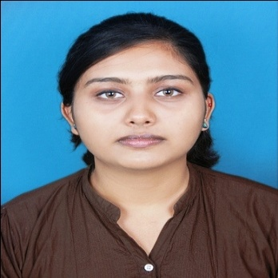
Poornima
E-mail: Poornima.361849@2freemail.com

Objective
Seeking a good career in this challenging world with committed and dedicated people, which will help me to explore myself truly and realize my potential.

Profile
A young dynamic and hardworking fresh graduate interested in the areas of biotechnology, lab assistance, clinical diagnosis. Highly organized, sharp & analytical thinker with strong communication skills.
Educational Qualifications
- Bachelor degree in Biotechnology from Bharathiar University, India during April 2016.
- Certificate course in MS Office from G- TEC Computer Education, India.
- Microsoft Office Specialist in Word 2010
- Microsoft Office Specialist in Excel2010
Work Experience
- Undergone 15 days training regarding Clinical Diagnosis.
- Undergone hands-on training program in various Clinical Biochemistry, Hematology, Serology, Microbiology and Histopathology Techniques .

Technical Proficiency
- Molecular Biology & Protein Techniques: Plasmid DNA isolation, Genomic DNA & m RNA isolation, AGE, PCR (Polymerase Chain Reaction), ELISA, Protein isolation.
- Chromatography: Thin Layer & Paper Chromatography and Column Chromatography.
- Immunological Techniques: ELISA, Immunodiffusion, Electrophoresis techniques.
Instruments Handled
PCR machines, UV Spectrophotometers, Calorimeters, Incubators, Centrifuges, Ultra centrifuges, Autoclave.

Skills
- MS Word, MS Excel, MS PowerPoint
- Good communication Skills
- Good telephone manner and client interface skills.
- Expert in assisting the seniors and manage the routine daily organization life.

Co-Curricular Activities
- Have attended and presented papers in several national seminars.
- Undergone training in several institutes related to the major subject.
- Elected as the student president in college Hindi Department.
Extra-Curricular Activities:
- Participated and won in various cultural and literary items in school and college level.
- Have won 3rd prize in Hindi inter-college paper presentation conducted by TOLIC, India.
- Secured 2nd rank in SOF International English Olympiad school level.

Personal Details
Nationality : Indian
Date of Birth : 14/04/1995
Gender : Female
Marital Status : Married
Languages known : English, Hindi, Malayalam, Tamil
Interests : Reading books, Social Networking, Travelling

