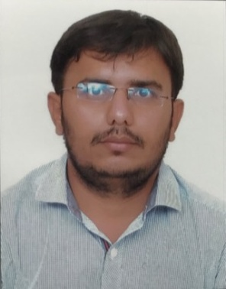
Curriculum Vitae

Ravi.
E-mail: Ravi.361862@2freemail.com

OBJECTIVE:
To succeed in an environment of growth and excellence and earn a job which provides me satisfaction and self development and help me to achieve organizational goal.

PERSONAL DETAILS:
- Date Of Birth: 25/06/1988
- Marital Status: Single
- Languages: English, Hindi, Gujarati
- Nationality: Indian
- Hobbies: Listening Music, and Playing Cricket , Travelling

- Visa Type: Visit.
- Visa Expiry: 04/04/2017

ACADEMIC RECORDS:

- S.S.C. from Gujarat Secondary Education Board (City High School) in March 2004.
- H.S.C. from Gujarat Higher Secondary Board (Kameshwar Higher Secondary School) in March 2006.
- Bachelor of Commerce (with Advanced Accounting and Auditing) from Gujarat University (N C Bodiwala Commerce & Arts College) in April 2009.
ACHIEVEMENT:
Best Performance of the Month in Velex Logistics Pvt .Ltd.
WORK EXPERIENCE:
- Flipkart Services Pvt. Ltd. (08/2015 – 11/2016)
- Responsibility: Hub Incharge.
- Handling Branch Operation Work to the Particular Branch.
- Handling Team Leader & Delivery Team Also.
- Handling Daily Finance Cash Report in Hub
- Daily Manage All Pending Shipments Reports,
- Maintaining MTD, (Month to Date Reports)
- Velex Logistics Pvt. Ltd. (12/2013 – 07/2015)
- Responsibility: Sr. Branch Operation Head.
- Handling All Branch Operation work.
- Handling Back Office Staff.
- Preparing Daily Banking Cash Report.
- Daily Preparing Pending All Reports,
- Preparing MTD, (Month to Date Reports)
- Angodis Export Ltd. (East Africa in Angola) (04/2012 – 10/2013)
- Responsibility: Sr. Operation Incharge.
- Handling Port Customs Clearation Work.
- Handling Backend Operation Staff.
- Preparing Daily Container Loading Unloading Report.
- Maintain Clients Data Record.
- Maintaining Month to Date Reports.
- L&T Infrastructure Development Projects Ltd. (12/2008 – 02/2012)
- Responsibility: Operation Executive.
- Handling Toll Collector & Toll Supervisor & Toll Auditor.
- Handling Cashier & Back Office Executive.
- Preparing Daily Banking Finance Cash Report.
- Maintain Money Transaction Data Record.
- Cash Daily Reports, Shift Rosters,
- Maintain SLA (Service Level Agreements).
- Maintaining MTD, (Month to Date Reports)

- Mphasis BPO Ltd. (05/2006 – 11/2008)

- Responsibility: Customer Service Associates.
- MIS Reports, Shift Rosters, Maintain SLA (Service Level Agreements).
- Handling Corporate Client Query.
- Maintaining MTD, (Month to Date Reports)
- Handling Customer issue & complaints
- Preparing Daily Customer Feedback Report

Place: Ahmedabad
Date:

