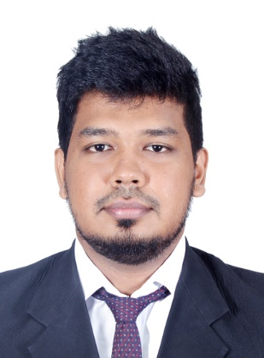

**Mohamed**

**Graduate IT Professional**

Email: [**Mohamed.361875@2freemail.com**](mailto:Mohamed.361875@2freemail.com)

**AREAS OF EXPERTISE**

**System Administration**

**Database Administration (MSSQL,MySQL)**

**HTML & CSS**

**PHP (Basics)**

**Network Administrating**

**Software Testing**

**Microsoft Windows**

**Windows 2003 Server**

**Windows 2008R2 Server**

**Windows 2012 Server**

**Firewall Administrating**

**Trouble shooting**

**Linux basics (Ubuntu)**

**CCTV IP camera technology**

**CAREER STATEMENT**

***“My Ultimate Goal is to excel myself in the field of IT industry. In my journey I expect to contribute in the maximum possible way to the organization which I’m going to serve. I hope the range of opportunities I get will enable me to sharpen my skills “***

Rizki azhar.

**PERSONAL SUMMARY**

A versatile and professional IT graduate with a commitment and experience of developing and managing IT infrastructures. Able to administrate network infrastructures, servers and hardware.

In my previous position as an IT executive, I’ve maintained an efficient and high performing attitude while providing consumer technical support service as well as the server maintenance of the organization and individual clients. I’m extremely good at analytical problems solving and work well with the team as well as independently, I’m well organized, proactive and a quick learner.

Actively looking for a system engineering position with a fast- paced and ambitious company that can offer development training, project based learning and a mentoring program.

**ACADEMIC QUALIFICATION**

2015-2016 BSc. (Hons) in Computing From London Metropolitan University at Esoft Metro Campus Srilanka.

2012-2014 BTEC Higher National Diploma in Computing and System Development from Pearson at Esoft Metro Campus Srilanka.

2011—2012 Certificate in Network Engineering at WinSys Network Institute Srilanka.

2008 Professional English course certificate level at National youth center Srilanka

**HIGH** **SCHOOL QUALIFICATION**

2011 – GCE Advanced Level Examination at St’lukes College Srilanka

2007- GCE Ordinary Level Examination at Dharmapala College Srilanka

**WORK EXPERIENCE**

**Chelcey Solution (Pvt) Ltd – Sri Lanka**

**IT EXECUTIVE (F/T) October 2014 – March** **2016**

Worked on a full time basis, for about 9 hours a day and 5 days per week, on Weekdays. Administrating the IT infrastructure of the organization, Introducing new IT solutions, Trouble Shooting, maintaining IT documentary, As well as helping with general administrative duties in the organization.

**Duties:**

Support LANs, WANs, network segments, Internet, desktop and intranet systems.

Ensure design of system allows all components to work properly together.

Maintain network and system security.

Evaluate and modify system's performance.

Maintain network servers such as file servers, VPN gateways, and intrusion detection systems.

Mobile Technology.

Administer servers (Windows 2008 R2 Server, Windows 2003 server), Database maintenance, desktop computers, printers, routers, switches, Untangle firewall, personal digital assistants, smartphones, software deployment, security updates, patches and CCTV.

Maintain integrity of the network, server deployment, and security.

OS installation & configuration.

Maintain IT documents & Files.

Implementation of new IT solutions & system upgrades for ensure the efficiency of the organization.   
Maintain system efficiency.

**PERSONAL QUALITIES**

Having a flexible approach and a can do attitude.

Quick Learner.

Highly motivated and organized.

Able to explain technical data to non-technical colleagues.

Have a good technical and analytical skill.

Ability to ensured projects run to schedule and budget.

Experience in training and mentoring junior and new staff.

**PERSONAL SKILLS**

**Attention to detail**

**Tactful and articulate**

**Problem solving**

**Team Leading**

**Planning strategically**

**Able to identify critical issues**

**Excellent organizational skills**

**PROFESSIONAL SKILLS**

First Aid

**PERSONAL DETAILS**

**Date of Birth:** 2nd April 1991

**Gender:** Male

**Nationality:** Srilankan

**Civil Statues:** Single