MAYANK
Web Developer

Mayank.361901@2freemail.com

COVER LETTER

Hello

Sir/ma’am,

My name is Maynak and having 3 years of experience in web designing and developement. I am a Self-directed and motivated Website Designer who works effectively in a dynamic environment. Fluent in WORDPRESS Framework, HTML, HTML5,CSS ,CSS3 and PHP. I am career oriented and unique driver for any web project .

- Handling clients to discuss the objectives and requirements

- Understanding the client’s needs and developing suitable concepts

- Estimating the amount of time needed to complete projects

- Developing different types of UI and layouts as per brand guidelines

- Produce excellent visual solutions

- Working with different types of media, including computer aided design, and photography

- Working alone or as part of a team as per the requirements of the project

- Collaborating with copywriters, photographers, and account managers to give the best service to the clients

Signature:
Mayank

MAYANK
Web Developer

Profile
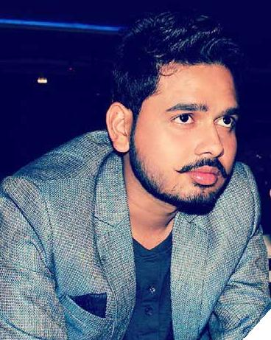

Date of Birth
07 12 1991

Married Status
Unmarried

Language

English, Hindi

Employment

Developer/wordpress Designer | Cruzon studios | 2014 - Present

- Researched, designed and implemented scalable applications for information identification, extraction, analysis, retrieval and indexing.

- Worked effectively with design teams to ensure software solutions elevated client side experience.

- Interfaced with business analysts, developers and technical support to determine the best requirement specifications.

- word press designer

• plugin customization

- theme customization

Web Developer(Trainee) | Heartz infotech | 6-Months

• Implemented designs, including experimentation and multiple iterations.

- Stored, retrieved and manipulated data for close analysis of system capabilities.

- .net /HTML /CSS learning

Proffesional Skills

Wordpress | 9.0

Wordpress customization 9.0

HTML & XML | 9.0
HTML5 | 8.0
SEO | 8.0
CSS | 7.0
Plug-in Customization | 9.0
Server Migration | 9.0

Personal Skills

90% 98% 95% 85%

Creativity Communication Team Work Coding

Web Developer

Who Am I ?

I am a Developer who loves to create visual stories. Currently i am working as a Wordpress Developer and Designer in Cruzon Studios.

Design trends keep changing and I like to keep myself updated with the same and also all the technologies that aid in designing and devoloping.

Why Choose me ?

I’m in love with wordpress

I like Coding & developing App

3 years experience in Designing and Developement

Equal balance of creative and analytical thinking.

Great liaison between technical and non-technical people.

Great Knowledge of UI & UX
Achivement

Employee Of the Year award | cruzon Studios | 2016

An Agency based award, i got it for best productivity in web.

Business Plan For a Start-Up

I Got a silver award in the category of ‘Best Business Plan’

Education

B.Tech in Information technology | 2009-2013

From satya group of institute, Palwal, India

- Top 80% of class

• Advanced Computer Science courses

- Seminar in Business Software Design

Intermediate in Science | 2011

I Completed my 12th with 74% from SVM College, Kanpur, India

