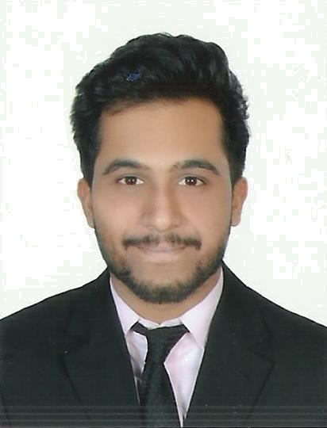
Rahul
rahul.361945@2freemail.com
Electronics and Communications Engineer
___________________________________________________________

Summary

I am an Electronics and Communications Engineer. I have worked at a global Management Consulting firm providing market research and analysis solutions for medical and pharmaceutical companies.

Core Skills

- Consulting
- Market Research
- Market Analysis
- Strategy

Work Experience

Merchandising Manager
R&B Clothing International Pvt Ltd.
March 2017 - Present
Job Description:
- Management of critical path delivery
- Following up production of orders placed with factories in India with daily communication
- Ensuring the team in India executes the contacted shipments on time
- Notifying any delays in shipment to the buyer in the U.K.
- Uploading the commercial invoices (FCRs) raised against export shipments made from India to the U.K. client on their B2B for securing payment

Associate Consultant
Orbees Business Solutions Pvt. Ltd.
July 2016 - March 2017
Job Description:
- Worked with a team to analyze the China market for major U.S. medical company to introduce a product to treat aortic stenosis.
- Led a project for a U.S. based pharmaceutical packaging company to introduce pouch packaging in U.S., Europe, Cana, Japan, and the Middle East.
- Have conducted interviews for college placements at NIT Warangal in 2016

Internship
Pacific Controls
July 2015 (1 month)
Job Description:
- Worked in the R&D Department, focusing on Internet of Things (IoT) projects.
- Learned about the basic IoT protocols such as MQTT, XMPP, CoAP, et al.
- Involved in the design and development of a gateway device, called the Galaxy 2021, which was used to sense fire alarms. This device, with the help of the UAE government and police, was fitted to serve every building in Dubai.
- Focused on various internet security protocols, such Open SSL

Computer Skills

- Programming Languages: C,C++
- Designing Tools: VHDL, OrCAD EE PSpice, AutoCAD
- Proficient in Matlab, NS3
- Documentation Tools: MS-Word, MS-PowerPoint, MS-Excel

Education

Bachelor of Technology in Electronics and Communications Engineering
National Institute of Technology Warangal, 2016

Extracurricular Activities/Other Attributes

- Event Manager for ‘Allure’ at college cultural festival, Springspree 2015

- House Captain at school for the 2011-2012 academic year

- Received a Gold Medal and a Trophy for consistently high academic performance in school for 7 consecutive years

- Received medals and a scholarship from school and the Indian Consulate, Sharjah for being one of the only four in school to achieve 10 CGPA in 10th Grade
- Represented the School Football Team, finishing runners up and semifinalists in the Our Own Football Tournament and the Clusters
- Came first in School General Quiz (2008), School Math Quiz (2009), School Public Speaking (2006), and second in Math Talent Search in 2005 and 2006

Personal Details:

- Date of Birth : 18 August, 1994
- Gender : Male
- Languages : English, Malayalam, Hindi, French (Basic)
- Valid U.A.E vehicle license

References

Available on request.

