CURRICULUM VITAE
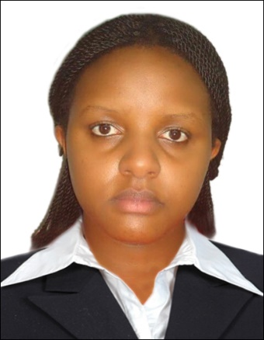
CYNTHIA

PERSONAL PROFILE

Contacts: Cynthia
Email: Cynthia.361957@2freemail.com
Nationality: Kenyan
Visa type : Visit Visa

EDUCATIONAL QUALIFICATIONS
2014 - 2015 Africa college of Aviation and Management
Diploma in Travel and Tourism (IATA)

2012 - 2013 Georgeal Technical college
Certificate in computer packages

2010 – 2012 Kagumo Girls Secondary School
Kenya Certificate of secondary education

CAREER OBJECTIVE.
To succeed in an environmental of growth and excellence and earn a job which provides me job satisfaction and self-development and help me achieve personal as well as organizational goals.

KEY SKILLS AND COMPETENCIES
- Able to write in a clear and concise manner and communicate effectively orally.
- Work in a multi-cultural, multi ethnic environment with sensitivity and respect for diversity.
- Able and open to learn new ideas and good interpersonal skills.
- Able to prioritize work and deliver assignments in an efficient and timely manner

Cynthia -Curriculum Vitae

WORK EXPERIENCE
6th Jan 2015 – Jan 2017: Scents Kenya Limited
Job Title: Sales Representative/ Cashier/ Customer Service Representative

- Key Responsibilities:-
- Ensure all customers receive outstanding service which follows the S.A.L.E.S process and mystery shop standards
- Maintain awareness of all promotions and advertisements.
- Execute the daily operational, day-to-day goals and priorities assigned by store management
- Assist in the training and development of peers
- Actively participate in daily huddle meetings
- Uphold merchandising and store cleanliness standards
- Participate in processing new shipments
- Help the team keep the receiving and back stock area clean and organized
- Notice and respond to safety issues
- Be conscious of shoplifting activity
- Know how to respond to shoplifters.
- Aid customers in processing special orders
- Answer customers’ questions and provide information on procedures and policies
- Tactfully and pleasantly deal with customers.
- Accurately and efficiently ring on registers and maintain all cash at registers.
- Maintain orderly appearance of register area and supplies stocked.
- Perform other tasks as assigned from time to time by store management.
- Issuing receipts, refunds, credits or change due to customers.

Cynthia -Curriculum Vitae

MAJOR ACHIEVEMENTS
- Become a deputy Head Girl in Kagumo Girls in the year 2011.
- Successfully promoted as the Head Girl in 2012
- Participated in a feed a child work in aid of Hope Centre, Kitengela 2011
- Attended a prefects workshops training in 2012
- Participated in a Kirinyaga region students leaders conference in 2012

ATTRIBUTES

- Good time management and leadership skills.
- Good communication and interpersonal skills
- Ability to work for long hours without supervision
- Ability to work comfortably in a challenging work environment and perform as a team player.
- Proactive - High driven –Vibrant Personality

CERTIFICATION
Cynthia certifies that to the best of her knowledge and belief, these data correctly describes her, her qualifications, and experience, and that she is equal to the task if accorded the opportunity.

Sincerely

Cynthia -Curriculum Vitae

