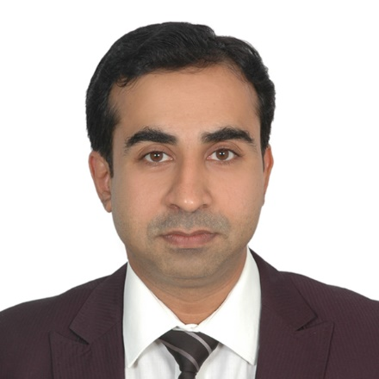
SAJID
SAJID.361972@2freemail.com
Database Development / System Analysis / Project Management
Pragmatic IT professional with strong work-ethic, approachability and consistent commitment to innovation
Core Competencies  Data / Database Analysis  System Analysis  Project Management  Integration / Modelling / Data Migration  Analysis, Development, Implementation & Maintenance of Applications  ERP Implementation  Object Oriented Architecture  Change Leadership |  | Profile Summary  - Visionary professional, leveraging of nearly 16 years of excellence in Database Management, System Analysis, Project Management and Business Analysis.  - Tenacious Business Analyst: Incisive acumen in gathering and evaluating information for business and functional requirement documentation, reconciling conflicts and ambiguities, and deconstructing high-level information into technical specifications and workflows  - Strong functional and technical experience in Air Cargo, Passenger System Services, ERP, Internal Audit System and Inventory System using SDLC & Agile processes.  - Possess comprehensive & proficient exposure in Elastic Search, Big Data Hadoop, Sqoop, Hive, Impala, Apache Pig, Flume, MongoDB and MicroStrategy.  - Sr. Oracle Applications Developer, enforcing security of all the Oracle Databases; maintaining database constraints to ensure integrity of the database  - Passionate & driven, showcased excellent aptitude as a capable business frontrunner in scaling, directing projects and translating business needs into technology requirements  - Combining technical expertise with strong business acumen and operational understanding; ensuring technical strategies & activities align with corporate goals  - Strong experience in work plan for team members, team leading, estimating change requests, preparing project status report and project management.
Technical Skills
Database: Oracle 12c, 11g, 10g, 9i/ 8i/ 7.x, SQL Server 2000 to 2012, MS Access, Elastic Search, Hadoop Big-Data
Warehousing Tools: Business Objects, TOAD, PL/SQL Developer
Applications/ Tools: C, C#, COM, DCOM, VB.NET, VB 6, Java, Harvest, SVN, JIRA, HPSD, HPSM, TABLEAU and MicroStrategy
Web Technologies: AJAX, JSON, XML, JAVA Script, VB Script, HTML, DHTM, ASP, ASP.Net
Operating Systems: Win10, Win7, XP, NT/ 2000/ 98

Career Timeline
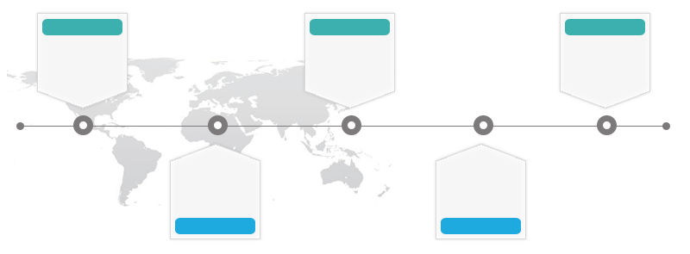
Rasasi LLC, Dubai, United Arab Emirates as Senior Developer
Sep’05-Jun’08

Since Jul’08
Emirates Airline (Dubai) as Senior Software Engineer

Jayesh InfoTech, Mumbai as Senior Developer

Jun’03-Nov’03

Dec’03-Jul’05
Software Creation, Mumbai, India as Senior Developer

Jun’01-May’03
Psyber System Company, Hyderabad as Developer
Certifications

- VB6, VB.NET, ASP, Oracle9i, SQL Server 2000 from Software Solution Integrated Limited (SSI), Hyderabad.
- C#, ASP.NET (Microsoft Certified) from Karrox, Mumbai.
- Hadoop Big-Data Certified Course from Edureka.
- MicroStrategy (Advanced Reporting, Dashboards and Data Discovery) from MicroStrategy Education, Dubai.
- Training with Software Solution Integrated limited (SSI), Karrox Mumbai.

Merits

Emirates Airline (Dubai)
- Credited by President of Emirates Airlines for exceptional contribution in key functionality in Audit Information Management (AIM) Online and Corporate Risk Register along with building various Continuous Monitoring (CONTACT) Analytics
- Gained recognition by:
- SVP Group Internal Audit for development of major functionality of Risk based Audit Approach (RBAP) Annual Planning (AIPM) and Continuous Audit Monitoring System
- Emirates Group IT Data Technology Head, NAJM for creation of Datathon using Elastic Search and Big Data

Work Experience
Since Jul’08 with Emirates Airline (Dubai)

Projects Executed:
- PSS (Passenger System and Services)
Role: Team Leader – Project controller
Period: Since March’16
Description: Utilized by various applications from Empact Program attain holistic view of customers like bookings, journey details and so on. Single source of truth for all customer information and for real-time data as well as analytical purposes
Environment: Oracle 12c, DB Cron jobs, Elastic Search and HDFS
Responsibilities:
- Managed data transmission service for the Business Reward System of Skyward using Oracle 12c, Elastic Search and Audit Logs
- Deployed ALCS Monitoring Tool using Oracle Database to interface various data from MACS & MARCS with end-to-end modules to RES, DCS, FQT and IBE Teams
- Created Central Online Repository ODS (Operation Data Store) to support real time interfaces of passenger check-in, booking, ticketing information in addition to complete flight level information from MACS, MARS System to other applications

- CONTACT (Continuous Testing & Analysis of Critical Transactions) and CRR (Corporate Risk Register)
Role: Team Leader- System Analyst
Period: Aug’10-March’16
Description: CONTACT (Continuous Testing & Analysis of Critical Transactions) System and CRR used by Senior Auditors of Emirates Group, other application data that produce critical exceptions which get published for senior auditor use related to continuous monitoring
Environment: Oracle 11g
Responsibilities:
- Designed various continuous monitoring analytics for Emirates Group Internal Audit using SDLC and Agile processes. The analytics are as follows:-
- Corporate Risk Register-risk profile, risk rating, activity and ECO system
- CRR Issue Dashboard-business issue and finding
- AWB Computation Reconciliation (NGSC Vs. RAPID) - AWB Reconciliation mechanism between NGSC & RAPID system to verify Net-rate that have a financial impact.
- Delay In AWB Verification - identifying delays in AWB Verification leading to potential risk AWB –
- Various analytic list-Delay in Billing, AWB - CCA Aging, AWB - CCA Profile, Delay In Deposit, Refund Exception Analysis, Time Sheet Planer, Petty Cash Analysis, Reconciliation between Sales vs. Collection, Station Level Supplier based Payment Profile, Payment Profile for Suppliers, F.O.P Analysis to consolidate and analyze all charges have been over-ridden
- Performed audit application tests and UATs to ensure release of robust and zero-defect solutions
- Prepared:
- High quality documentation to accompany the software release via change management process
- Various analytics on Oracle Financial - ERP, SkyChain, RAPID, MARS and Gunnebo using Oracle11g
- Rendered post deployment support production environment
- Imparted technical assistance and reviewed the code of the team
Drove creation of new database objects such as tables, indexes, views, triggers, functions, stored procedures and so on using Oracle 11g
- Conducted system analysis, design and testing, data modelling and created Database Design (Packages, Stored packages, Functions and Triggers using SQL and PL/SQL)
- Coordinated with Internal Audit users to map business requirements as per Emirates Group Policy and integrated with CONTACT Framework (Continuous Testing & Analysis of Critical Transactions), Corporate Risk Register, Issue Register and Audit Console with Audit Team for exception identification

- ePACTS (Central Services)
Role: Senior Software Engineer
Period: Jan’10 -Jul’10
Description: Electronic Passenger and Crew Transportation System has two modules Passenger & Crew Transportation. Passenger module facilitates information from MARS for F and J class passengers. This will contain the full list of passengers who has booked Limo car services in the flight. Dispatched to ePACTS at 40 hours before departure of the flight and process data to third party system called Vehicle tracking System.
Environment: Oracle 10g
Responsibilities:
- Developed new database objects: tables, indexes, views, triggers, functions, stored procedures and so on using Oracle 10g
- Monitored development of new Adhoc Request Transport Module for crew transportation
- Brought enhancement in ePACTS system in compliance with new security standards proposed by The Security and Risk Management Team

- New Generation Cargo System (NGCS)
Role: Senior Software Engineer
Period: Jul’08-Jan’10
Description: User-friendly, highly secure, transactional application that contains all the functionalities required for cargo management. To incorporate integrated modules of functionality present in the existing suite of disparate systems as well as new value-added functionality providing new levels of automation to deliver significant improvements & efficiencies.
Environment: Oracle 10g and SQL, PL/ SQL
Responsibilities:
- Created:
- New database objects such as tables, indexes, views, triggers, functions, stored procedures with Oracle 10g
- Import Utilities
Sep’05-Jun’08 with Rasasi LLC, Dubai, United Arab Emirates as System Analysis and Senior Developer
Project Executed:
- Enterprise Resource Planning (ERP)
Role: Senior database developer and system analyst
Period: Sep’05 –Jun’08
Description: ERP system was developed for a big manufacturing company entailing entire department module of Purchase, Marketing, Production, Blending, Store Components, Store Finished Product, Quality Control, Packaging, Accounts, Personal and Logistics Department.
Environment: VB.NET, ASP.NET, SQL Server2000, 2005 and Seagate Crystal Report 2008
Responsibilities:
- Conducted analysis of EPR functional specifications
- Developed:
- New database objects such as tables, indexes, views, triggers, functions, stored procedures using SQL Server 2000, SQL Server 2005
- Export, Backup Utilities using SSIS and Reports, Cubes in SSRS using SQL Server 2005
- Enforced login on the server side with SQL store procedure
- Transitioned database objects from SQL Server 2000 to SQL Server 2005
- Determined operational feasibility by defining the problem, analyzing requirements, and assessing proposed solutions
- Undertook documentation of each module for user level and system level maintenance

Dec’03-Jul’05 with Software Creation, Mumbai, India as Senior Developer
Project Executed:
- Laboratories Management System (LIMS)
Period: Jan’05-Jul’05
Description: LIMS assists in Testing Laboratories in their three basic functions of Registering, Analysis and Certifying samples. It automates the collection, storage tracking and reporting of data on samples submitted to the laboratory for analysis. Analysis result can be entered manually or automatically through instrument interfaces.
Environment: Visual Basic 6.0, Oracle 9i and Seagate Crystal report 9.

- Machine Downtime Monitoring System
Period: Dec’03-Dec’04
Description: This system is for Copper Wire Manufacture Industry to computerize all functions of manufacturing copper wire. It includes Electrical, Mechanical and Production sections. It calculates overall equipment efficiency of machine and production loss with the help of machine’s speed, size, shift of gang and defect occurred. System generates report on overall equipment efficiency in terms of overall enameling velocity (OEV), overall enameling changeover (OEC), overall enameling breakage (OEB), analysis report of department wise downtime comparison with Top-N defects and also shows the pictorial representations.
Environment: VB, SQL Server2000 and Seagate Crystal Report 9.

Responsibilities:
- Optimized system/database operations and resource utilization; performed system capacity analysis and planning
- Managed the development and execution of scripts to insert static records using SQL*Plus
- Executed business rules by writing PL/ SQL functions, procedures and trigger
- Wrote complex SQL’s using joins, sub queries and correlated sub queries

Previous Experience

Jun’03-Nov’03 at Jayesh InfoTech, Mumbai as Senior Developer
Project Executed:
Tourism System
Description: Made for Tours and Travel Company in a large scale to computerize all functions of a tourism management through various modules created. The modules included Address Book, Hotel, Itinerary, Voucher, Domestic Airlines, International Airlines, sightseeing and Visa.
Environment: Visual Basic 6.0, SQL Server 2000 and Seagate Crystal Report 8.5

Jun’01-May’03 at Psyber System Company, Hyderabad as Developer
Project Executed:
Warehouse BOS & POS System
Description: Package made for supermarket and textiles showrooms, divided into two module BOS and POS. BOS is back office software and POS are used as front office software. It is capable of maintaining the inventory of multiple outlets.
Environment: Visual Basic 6.0, SQL Server 7, Oracle 8i and Seagate Crystal Report 8

Education

- Pursuing MBA from Varoda, India
- Bachelors in Science (Computer Science) from Nagpur University, India in 1998

Personal Details

Date of Birth: November 1975
Languages Known: English, Urdu, Hindi, Marathi and Gujarati
Address: Sajid Z Saiyed, P.O. Box-686

