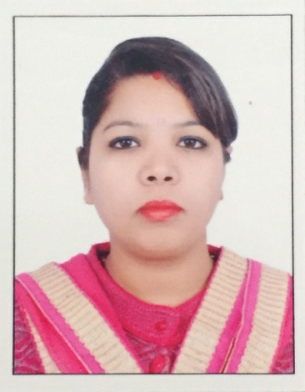
RUPALI

rupali.361997@2freemail.com
CAREER OBJECTIVE
A professional and challenging career which will provide me opportunity to grow in the corporate world using my knowledge and skill, and enhance my strength to achieve my as well as organizations goals.

Teaching Experience 4 year approx. of Science and English

CAREER PROFILE
- Raawia Para Medical Institute, Nakodar- Lecturer
(10th June 2013 to 5th March 2017)

- Dr. Mandeep Singh Aneja Dental Clinic Nakodar- Jr Assistant Dentist
(1st January 2011 to 13th April 2013)

- Cleared IELTS Exam TWICE with overall 7 bands

- Teaching Experience in IELTS ( 8 Months )

SUBJECTS TAUGHT
- English
- Science & Biology
- Anatomy & Physiology
- Medical and Dental related all subjects

DUTIES AS A TEACHER
1. Developed and implemented daily and unit lessons plans, administered tests and evaluation and analysed student performance
2. Conducted group / individual reading, learning and practical activities
3. Fostered a classroom environment conducive to learning and promoting excellent students / teacher interaction
4. Participated in faculty and parents interaction
5. Make student understand the subject by conducting camps and practical classes.

DUTIES AS A DENTIST
1. Supervise dental hygienist, dental assistant and the other working staff
2. Examine teeth, detect disease and plan proper treatment
3. Aids in maintaining proper oral health
4. Clean teeth and instruct the patient about oral hygiene
5. Write fabricature instructions or prescriptions for the use of dental assistants and
Patients
ACADAMIC PROFILE
COURSE | INSTITUTION | BOARD | PERCENTAGE | YEAR OF PASSING
BACHELOR OF DENTAL SURGERY (B.D.S) | GENESIS INSTITUTE OF DENTAL SCIENCES AND RESEARCH FEROZPUR | BABA FARID UNIVERSITY OF HEALTH SCIENCE FARIDKOT | 65% | 2010
10+2 SCIENCE | K.R.M.D.A.V COLLEGE, NAKODAR JALANDHAR | PUNJAB SCHOOL EDUCATION BOARD | 73% | 2004
SSLC | DAYANAND MODEL SENIOR SECONDARY SCHOOL, NAKODAR, PUNJAB | CENTRAL BOARD OF SECONDARY EDUCATION, PUNJAB | 70% | 2002

TRAINING AND CERTIFICATION
- Certificate of Registration from Punjab Dental Council, Registered Dentist under the provisions of the Indian Dentists Act.1948 (Reg. No.: 8169-A (p b.)
- Qualified in International English Language Testing System ( I.E.L.T.S- 2011 and 2014)

STRENGTHS
- Having good leadership quality and ability to organize events
- Good communication skills and public speaking capabilities
- Self-Motivating personality
- Willingness to learn and Quick in grasp
- Perseverance and Hard working

I hereby declare that all the information furnished above is true to best of my knowledge and belief.

