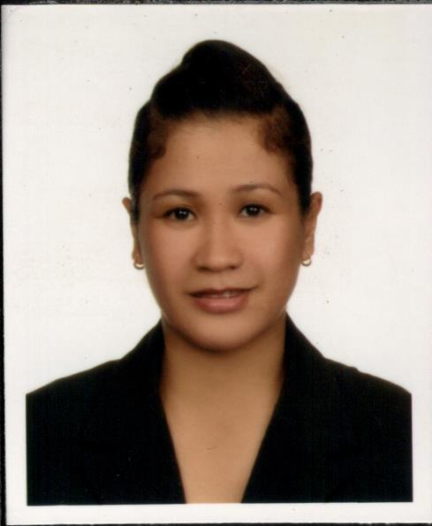

Amy

C/o-Mobile #: +971503718643

E-add :amy.36304@2freemail.com

Objectives:
To have advancement with my profession and achieve better career not just in a progressive organization but in other aspect wherein. I can implement and explore at the same time. To share my knowledge for the benefits of the company.

WORK EXPERIENCE:

Cashier cum Waitress - Smana Hotel Al Raffa
Dubai, UAE
August 2013 - October 2016

Duties and Responsibilities:

- Managing all the cash transaction in their work place
- Maintaining daily account o0f the daily transaction
- Balancing the daily account at the end of each day
- Checking the daily cash balance
- Interacting with the costumers that come to the counter
- Solving all their cash related queries
- Checking for the price of products and any discounts or offers
- Receiving coupons and deducting the said amount from the costumers
- Organizing all the work they do and maintaining the accounting records

Waitress - Manhattan Hotel
Dubai, UAE
June 2010 - July 2013

Duties and Responsibilities:
- Responsible for the service of beverages to the guests in a friendly and courteous manner I n all therestaurants or bars.
- To provide efficient, expedient and courteous service to the guests leading to total guest andcompany satisfaction.
- Responsible for the cleanliness, maintenance and upkeep of all equipment, furniture, stations
- To check all glasses, crockery and other items needed before putting them in use.
- Responsibly minded for the breakage and loss of such items.
- To ensures that all items required for the set-up of each table are clean, unspotted andin place.
- To respect my Superiors, accept requests withoutquestioning, co-operate unselfishly, and be a good team worker.
- To be courteous, warm, smiling while dealing with guests. Be efficient, fast and serve withconfidence and flair.
- Familiar with all menu items, their preparation and service procedure.
- To make sure that all beverages are according to menu and list specifications, properlypresented and be of correct temperatures before being served.
- To listen to guest complaints. Rectify wrong doings and any guest demands. Inform

Saleslady - Sta. Lucia East Grand Mall
Manila, Philippines
February2008 to 2009

Duties and Responsibilities:
- Key holder responsibilities
- Achieving set sales targets on a weekly basis
- Providing an outstanding level of customer service
- Ensure a high level of appearance on the shop floor
- Offer a consultative approach to your clients
- Build a strong client database
- Undertake other duties as and when required

EDUCATIONAL BACK GROUND:

- Bachelor ‘s Degree ( Secretarial - under graduate)

PERSONAL IMFORMATION:

- Date of birth: July 1, 1977
- Age:37yrs old
- Civil status:Single
- Citizenship:Filipino
- Language:English, Tagalog
- Visa status: Tourist Visa

I hereby certify that the above information is true and correct to the best of my knowledge and belief.

