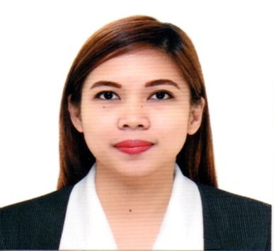
ARLENE

Arlene.36783@2freemail.com

OBJECTIVE
To obtain a position as a Medical Practitioner, develop my nursing skills, to provide the highest level of care for clients, and where I can make a positive contribution to the institution.

CORE COMPETENCIES
Strong Sense of Leadership and Teamwork; Hardworking and energetic, Possess critical thinking skills essential to provide competent and dignified care that enriches patient’s life, highly dependable and reliable. Committed to those in need of care.

PERSONAL INFORMATION
Birthday:  Civil Status:  Nationality:  Height:  Weight:  Religion:  Spoken Languages: | February 10, 1991  Single  Filipino  5’ 3”  46 kg  Roman Catholic  English, Filipino (Tagalog and Bikol)

WORK EXPERIENCE
NEPHROLOGY CENTER OF BICOL, INC.
Hemodialysis Nurse Trainee: February-October 2015

OUR LADY MEDIATRIX HOSPITAL, IRIGA CITY
Volunteer Nurse: January-July 2014

BUHI COMMUNITY HOSPITAL, BUHI,CAMARINES SUR
Staff Nurse: February-December 2013

SUMMARY OF SKILLS
Technical (Medical)  Languages  Other Skills | - Blood Pressure and Neurovascular monitoring; Intravenous Fluid Transfusion; Blood Transfusion; Nasogastric/Osterized Feeding; Endo-Tracheal Suctioning; Parenteral Administration of Medications; Proper Documentation of Nursing Care, etc.  - Efficient, and fast in oral and written communication  Filipino, English  - Computer Literate in MS Office and Video & Audio Creation Presentations  - Fast Learner in the system and procedures of office work flow  - Goal-Oriented on all aspects covered by work

EDUCATIONAL ATTAINMENT
Date: June 2008 – March 20012 (Tertiary)
Bachelor of Science in Nursing
Camarines Sur Polytechnic Colleges, Nabua, Camarines Sur
Batch 2012

Midwifery
Camarines Sur Polytechnic Colleges, Nabua Camarines Sur
Batch 2010

1 year Certificate on Health Aid
Camarines Sur Polytechnic Colleges, Nabua, Camarines Sur
Batch 2009

Date: June 2004 – March 2008 (Secondary)
St. Bridget School
Buhi, Camarines Sur, 2008

Date: June 1997 – March 2004 (Primary)
Buhi Insitute Foundation
Buhi, Camarines Sur, 2004

EXAMINATIONS TAKEN
Title of Examination: Philippine Nurse Licensure Examination
Date: December 2012
Result: Passed

Title of Examination: Philippine Midwifery Licensure Examination
Date: April 2010
Result: Passed

TRAININGS/SEMINARS TAKEN
April 25-27, 2014  March 8, 2014  March 8, 2014  March 8, 2014  October 19-20, 2013 | Basic Intravenous Therapy Training Course  OLMH Conference Hall,  Our Lady Mediatrix Hospital, Iriga City  “The Shape of Humanity: Know Thyself” Theme:“Nurses of Today, Transforming the Nursing of Yesterday to a More Competent and Broader Nursing of Tomorrow”  Camarines Sur Polytechnic Colleges,  Nabua, Camarines Sur  Nursing Leadership Applied in Clinical Setting  Camarines Sur Polytechnic Colleges,  Nabua, Camarines Sur  Current Trends and Issues in the Nursing Practice  Camarines Sur Polytechnic Colleges,  Nabua, Camarines Sur  Basic Life Support Training for Healthcare Providers  OLMH Conference Hall,  Our Lady Mediatrix Hospital, Iriga City

PERSONAL SKILLS
Languages  Other Skills  Related Hobbies and Interest | - Efficient and fast in oral and written communication  Filipino, English  - Computer Literate in MS Office and Video & Audio Creation Presentations  - Fast Learner in the system and procedures of office work flow  - Goal-Oriented on all aspects covered by work  - Reading books, Singing and Dancing

I hereby certify that the above information is true and correct to the best of my knowledge and belief.

