Mapple.37187@2freemail.com 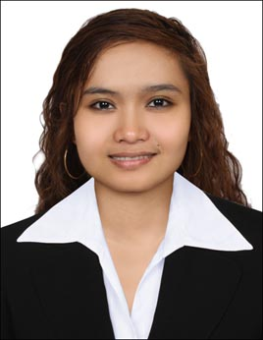
Mapple

OBJECTIVE:

To achieve challenging growth in a position that will enhance and utilize the experience and education through achievement of both company and personal goals and opportunity for advancement will commensurate with demonstrated ability and accomplishment where my skills and experience will be fullest, contributing to the growth and success of the company.

Work Experienced:

Administration Secretary DAR AL HIKMA
PRINTING, PUBLISHING & DISTRIBUTION LLC
Dubai, United Arab Emirates

As an Administration Secretary:

- Administering clerical works such as filing, typing and other computer works.
- Receiving e-mails and forwarding to each respective Departments, follow up for correspondence and sending e-mails.
- Make and arrange appointments for the C.E.O.’s meeting.
- Following and implementing Office/Company’s rules and regulations.
- Coordinating to the Manager, Departments, Sections and Clients.
- Receiving incoming and outgoing phone calls, e-mails and fax.

Call Center Agent Sutherland Global Services
Community Language Specialization Program
Tarlac City, Philippines
May 2013 – October 2013

Educational Attainment:

College Central Luzon Doctors Hospital – Educational Institute
Bachelor of Science in Medical Technology
San Pablo, Tarlac City Philippines
Year 2008 - 2012

Secondary Cosmopolitan Institute
C. Santos St. Tarlac City, Philippines
Year 2004 - 2008

Elementary Cosmopolitan Institute
C. Santos St. Tarlac City, Philippines
Year 1999 - 2004

I hereby certify that the above mentioned information is true and correct to the best of my knowledge and understanding.

