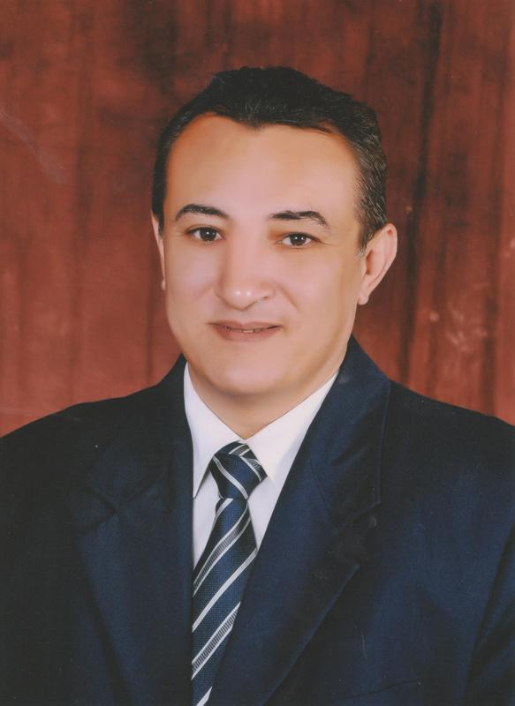
Curriculum Vitae

Objective:
Seeking career opportunity in a privileged working environment in a multinational firm where I can best utilize my accounting, auditing background, interpersonal, and communication skills to contribute to the growth of the firm.
Personal Information:

Name : Selim
Email :- Selim.362002@2freemail.com
Date of birth : Nov 23th, 1971
Nationality : Egyptian
Marital status : Married
Nationality : Cairo, Egypt

Educational Background:

- CPA – Certified Public Accountant California Board of Accountancy, CA , USA, Nov 2001
- Financial Accounting Diploma Faculty of Commerce , Ain shams University, May 1996
- BSC Commerce, Faculty of Commerce, Ain-Shams University,
- MAJOR: Accounting Section May 1993
- Fluent in both English & Arabic
- Egyptian Society of Accountants & Auditors - COURSE: Egyptian Auditing And Accounting Standards Proficient with a vast array of Computer Skills including
- Computer packages MS Word, Excel, PowerPoint, Access, Outlook & Internet
- Audit Assignments Deloitte
- Audit Supervisor
- Instructor

Language skills:

Arabic: Fluent all aspects, Mother Tongue
English: good Oral and Written

Computer Skills:

Experienced in windows soft ware Devices installing
Experienced in using access work sheets: data entry
Experienced in E-mail and Internet Search, network applications

PERSONAL SKILLS:

Able to work using own initiative, independently and efficiently under pressure, and to meet deadlines.
Accustomed and experienced in handling Customer’s and Client's enquires and complaints, whilst knowledgeable of the Company's Services, Products and availability.
Capable of using Computers, Printers, Scanners and other modern office tools.
Able to adapt to changes in the work environment and workplace.

Training:

- Egyptian Society of Accountants & Auditors - COURSE: Egyptian Auditing And Accounting Standards
- Proficient with a vast array of Computer Skills including.
- SAGE Line 50 Financial Controller
- AS2 Audit System 2 (DT&T Audit Approach)
- Sun System
- Microsoft XP & Vista
- Microsoft office 2003 & 2007.

Working Experience:

February 2014till now, Global View – HSA Consultants & Public Accountants
Audit Director
- Participated as an director of the auditing team for companies in different lines of business, Industrial, service, construction, hospitality and Banks
- Prepare the Audit Plan, timing and staff required for all clients
- Review the understanding of the business and evaluation of the internal control of the client
- Following up the work of the audit managers
- Attend the board of directors and the general assembly meeting for the clients
- Involving in the professional training for the audit staff
- Review and comment on the audit file with the audit managers.
- Ensuring that the financial statements of the clients were prepared according with the IFRS.
- Handover the audit files to the audit partner.
- Attend the trainings performed by the firm locally and globally.
- Evaluate the audit staff in a quarterly basis

March 2011 till December 2013, Hedley International Emirates Contracting & Industrial, Financial Controller, Abu Dhabi, UAE.
- Preparing financial reports, budgets, cost reports and financial forecasts on a regular basis according to the accurate data received from the operating departments.
- Overseeing the accounting staff, and the financial analysts
- Mentoring accountants for purposes of ensuring that their accounting and analysis duties are done well
- Ensuring that the financial records are accurate
- Ensuring that every expense is properly documented
- Ensuring that the books of accounts are compiled every end of the month
- Ensuring that the books of accounts are compiled at the end of every financial year
- Working with staff in the accounts department in determining the level of profitability of the company within a specified time
- Ensuring that there is fiscal responsibility within the firm’s operations
- Ensuring that the decision makers in the firm understand the financial implications of the missions they set for their company in a specific period
- Held accountable for any financial decisions made in the firm because he is the ultimate authorizing entity
- Approves finances to be used in specific projects by the firm based on estimates made by the accounting department
- Responsible for the budgetary control in a specific firm
- Corresponds with the senior management regarding any financial decisions that are made

January 2007 till January 2011 UK Hotel Holdings FZC , Financial Manager Dubai UAE,

- Responsible for all financial & accounting activities for the business in accordance with IFRS.
- Oversees daily operations performed by the Accounting Department including accounts receivable, accounts payable, fixed assets, payroll and petty cash.
- Oversees the whole purchasing process to ensure the timely and efficient procurement of goods and services for all Company departments at the best price/quality ratio
- Manages the Company’s cash flow, and provides the GM with frequent reports, as needed, on the Company’s cash flow status.
- Develops an administrative and financial adequate internal control and reporting system
- Analyze cash flow, cost controls, and expenses to guide business leaders. Analyze financial statements to pinpoint potential weak areas
- Ensure that the contractors certificates of payments matching with their respective contracts
- Performing negotiations, seeking facilities from banks and oversees the banks accounts along with the monthly bank reconciliation.
- Responsible for monthly closing and prepare the management reports
- Prepared the company policies and procedures
- Dealing with the external auditors.

April 2003 – December2006 LIN SCAN Advanced Pipelines & Tank Services
Financial & Administration Manager, Ajman, UAE

- Prepared Chart of Account
- Set up Internal Control procedures
- Set up the inventory System.
- Implementing New Accounting System
- Preparing & Discussing annual Budget with operation & Production Department
- Cash Flow management & preparing projected Cash Flow.
- Creating the weekly and monthly reports to communicate financial & Credit issues to the management partner.
- Responsible for all financial & accounting activities for the business in accordance with International Financial Reporting Standards, including preparing month-end financial Statements.
- Supervision & Authorization of daily transactions.
- Responsible for authorizing items to be capitalized

April 2005 – August 2005 Dubai University College Instructor Dubai, UAE

Courses:
- Principles of Accounting
- Auditing
- Financial Statement Analysis
- Intermediate Accounting
- Accounting Theory

April 1996 - March2003 DeloitteAudit Supervisor Cairo, Egypt.

- Participated as a supervisor of the auditing team for companies in different lines of business, Industrial, service, construction, hospitality and Banks.
- Obtain an understanding of the client’s Operation, Business & Industry
- Perform Preliminary Analytical Procedures
- Consider Preliminary Engagement Materiality
- Preparing Audit Planning and Strategies.
- Discussing Audit Plan With The Manager
- Assess Engagement risk
- Determine and prepare the work Program Defining the nature, timing, & extent of the procedures to be applied.
- Obtain & Document an understanding of Internal Control
- Supervision of the audit team throughout the auditing process
- Evaluating The Audit Team Work
- Review the Engagement to Provide Reasonable Assurance that objectives are achieved and Evaluate Information obtained to reach and to Document Engagement Conclusions
- Preparing Management Reports
- Preparing Audit Reports
- Attending The General Assembly Meetings
- Using D&T computer audit approach throughout the Auditing

