MUSTAFA
UAE- Dubai  MUSTAFA.362011@2freemail.com |  |  | Birth Date : 22-04-1993  Marital Status : Single  Nationality : Turkey  Driving Licence : Light  Vehicle (UAE) | 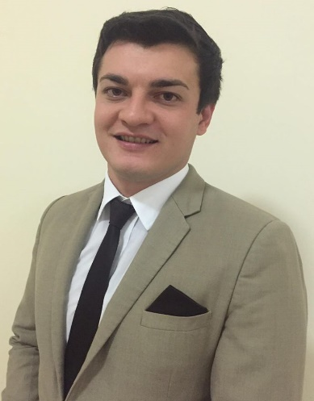
CAREER OBJECTIVE
A challenging position in dynamic environment with growth company. To enhance my professional skills in the best possible way for achieving the company’s goals and allow me to grow professionally and as an individual.

WORK EXPERIENCE
July 2015- Current |  | The Addresss Dubai Mall-Dubai-UAE  Senior Executive Lounge Agent/ Promoter  - Set up meetings with potential clients and listen to their wishes and concerns.  - Interview clients to determine what kinds of properties they are seeking.  - Prepare and deliver appropriate presentations on products/ services.  - Responsible for pre-arrival communication with Executive Lounge Guests and arranging for all guest requests and preferences  - Achieve agreed upon sales targets and outcomes within schedule.  - Concierge services( Assists with making arrangements for VIP guests including restaurant, club, entertainment and all other reservations)  - Supply management with reports on customer needs, problems, interests, competitive activities, and potential for new products and services.  - Listen to complaints put forward by guests, resolve stressful situations and provide solutions to problems  - Attend to guests' queries, needs and other special requests  - To assist Guests with general enquires and any other reasonable service requested by guests  - Project a professional manner with an emphasis on hospitality and guest service
October 2014 -June 2015 |  | RIXOS Hotel Bab Al Bahr- Ras Al Khaimah -UAE  Sport Entertainer  - Interact with the guests in a professional manner on a regular basis  - Organizing sport activities in different sports  - Participate in the daily activities in the swimming pool, gym, and on the beach.  - Be Familiar with all local attractions, hotels, etc.  - Moderates evening programs and shows in different languages  - Open and close the activities centre on alternating days.
April 2012 - 2014 August |  | HILTON Izmir - Turkey  Sales Representative  - Build credible and lasting relationships with prospects and customers for repeat business  - Maximizing up selling opportunities by proposing  - Providing information about tourist destinations and points of interest.  - Identifying package deals and promoting guided tours  - Arranging transportation for p/up & drop off service.  - Meeting sales targets  - Selling tours to all destinations within Izmir - Istanbul & Turkey  - Implementing and executing all sales objectives and action plans to reach and exceed targets set.
November 2011 - 2012 March |  | KOTON Izmir- TURKEY  Sales Attendent  - Providing a friendly and helpful service to customers.  - Supporting the store team and manager to increase revenue streams.  - Experience in using effective selling techniques, capable of up-selling and promoting  - Built up good working relationships with suppliers, customers and colleagues  - Unpacking and checking of all new deliveries to the department  - Approaching customers that may require assistance.  - Demonstrating good product knowledge to customers on key promotions and offers.
March 2009 - 2011 October |  | BELCEKIZ Beach Club Hotel-Fethiye- TURKEY  Receptionist  - Coordinates room status updates with the housekeeping department by notification housekeeping of all check outs, late checkouts, early check-ins, special requests, and day use rooms.  - Uses proper mail, package, and message handling procedures , courier mail register.  - Knows room locations, types of rooms available, and room rates.  - Register guests and assigns rooms. Accommodates special requests whenever possible.  - Understands room status and room status tracking.  - Performing cashier related functions like posting charges to guest accounts, raising paid out's, currency exchange,  - Assists in preregistration and blocking of rooms for reservations.

EDUCATION
Faculty |  | Anadolu University - Business Administration  Eskisehir - TURKEY
High School |  | Nevvar Salih İsgören Anatolian Hotel Management and Tourism Vocational High School -Customer Relations  İzmir- TURKEY

LANGUAGE SKILLS
Turkish | Native
English | Fluent
German | Fluent
Russian | Fluent

