Infos

26 years old

Driver's Licence

About Me

I graduated with a Master degree in Operations Research and Management Risk Negotiation from the university of sciences and technology Houari Boumediene (USTHB) and another Master degree in Industrial Economics of Networks and Infrastructures from the National School of Management of Kolea, I am in training in engineer specializing in petroleum economy ( Procurement ) at National Company of Research, Production, Transport, Transformation and Marketing of Hydrocarbons SONATRACH, I have undergone a multifaceted training with some training that helped me develop my skills and discover my strengths. I am serious and rigorous, I like to work in a team and dynamic.
Abdenour
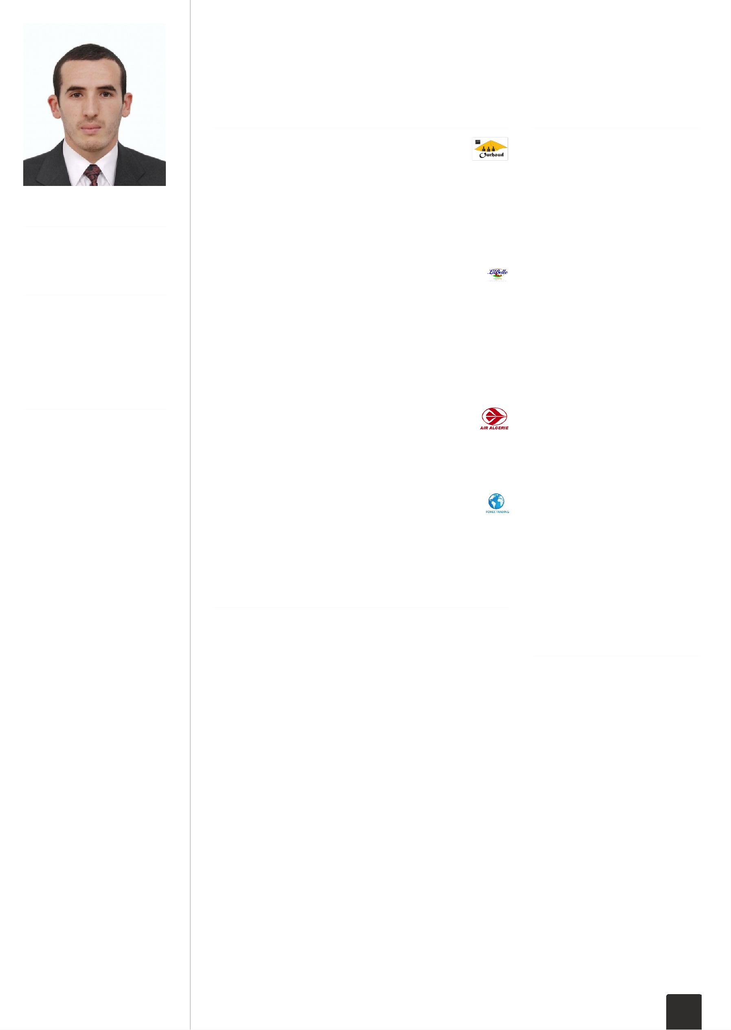
Abdenour.362014@2freemail.com
Procurement Engineer

EXPERIENCE

Procurement Engineer

Sonatrach Ourhoud Organization July 2015 to June 2017

The main task is to ensure the smooth running of the purchasing activity from the upstream to the downstream, in compliance with the rules and procedures pre-established by the company.

Fonction : buyer,Purchaser

Traineeship Groupe LABELLE

Groupe LABELLE March 2015 to June 2015

Study the advertising strategy of the Company Groupe LABELLE Analyzing agro-food industry

Analyzing Coffee market

End-of-study Master Degree report entitled: Advertising as a Competitive Strategy in the Agro-Food industry

Graduation internship of Master degree

Traineeship Air Algérie

AIR ALGERIE January 2013 to August 2013

Optimization of transport planning for flight crews Graduation internship for Master degree

Traineeship Forex Trading

Market Trands July 2011 to August 2012

Learn How To Trade The Market Using different trading methods

EDUCATION

Petroleum Economy ( Procurement)

Algerian Institute of Petroleum February 2016 to June 2016

Develop the specialization and expertise in the areas of finance, procurement, petroleum economics, petroleum taxation and project management

Master degree Industrial economics of networks and infrastructures

National School of Management of Kolea September 2013 to June 2015

*The aim of this master's program is to train a new generation of teacher researchers working in LMD-type training. Providing specialists in industrial economics who may accompany reforms in the telecommunications, energy and transport infrastructure sectors; Banking and finance and industrial project management. *End-of-study Master Degree report entitled: Advertising as a Competitive Strategy in the Agro-Food industry

SKILLS

Languages

English French Arabic

Operating System

Windows (Seven / Eight /
Ten )
Linux / Ubuntu

Knowledge and skills in Computing

Perfect command of
computer tools;
Perfect command of
Programming languages
(Matlab, Caml, Workplace
(Latex));
Skills in
Delphi,Java,Pascal,C++;
Project Management
Software (MsProject
Microsoft).

Office tools

Microsoft Word, Excel,
Power point
Oracle

Trading market

Forex Trading

INTERESTS

Cinéma

Movies and series

Musique

I listen to every kind of music

Voyages

I love travelling

Sport

Swiming Judo

Volley-ball Soccer

1 / 2

Master Degree Operations Research, Management, Risk and Negotiation (ROMARIN)
University of Sciences and Technology HOUARI BOUMEDIENE September 2011 to June 2013

End of Study Master Degree report entitled : Optimization of transport planning for flight crews

Rating: Very good

Bachelor's Degree 3 in Computer Science

University of Sciences and Technology HOUARI BOUMEDIENE September 2010 to June 2011

During this training, lessons are specialized and are aimed, firstly to complete the knowledge, concepts and techniques acquired during the first two years, and secondly to give the desirable practice opening face to management and decision-making problems in the industries and the economic world.

Bachelor's Degree 1 in Computer Science

University of Sciences and Technology HOUARI BOUMEDIENE September 2008 to June 2009

The training is based on the general learning of mathematics such as algebra and analysis as well as computer science as programming Languages like Pascal. Other courses are proposed to enrich the training include physics and machine structure.

Bachelor's Degree 2 in Computer Science

University of Sciences and Technology HOUARI BOUMEDIENE September 2009 to June 2010

This training make me learn to handle the most important tools of the Operational Research, to diversify his knowledge in Mathematics and Computer and use new programming language and software.

Baccalaureate in Mathematics

High school Baha Mekaoui September 2007 to July 2008

The training is accentuated on the mathematics and its maneuverability in order to have the skills required to follow higher studies in the mathematical field.

2 / 2

