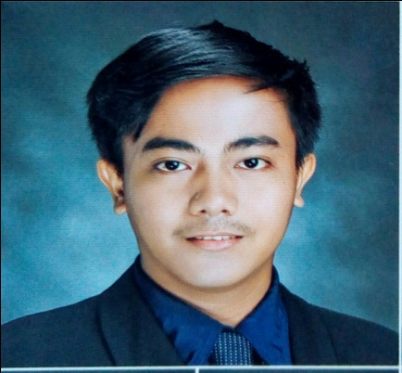
PHILIP
PHILIP.362027@2freemail.com
OBJECTIVE:
To have a good learning experiences and wants to open more opportunities for myself in the future. I want to go through challenges. Achievements are my goal. I also want to apply and improve my knowledge and skills. In addition, I am eager to contribute my creativity and hardwork towards the success of the company and to the growth of the fast developing field.
EDUCATIONAL BACKGROUND:

College: TARLAC STATE UNIVERSITY
Romulo Boulevard, Tarlac City
Course: Bachelor of Science in Information Technology
2012-2016
Secondary: TARLAC NATIONAL HIGH SCHOOL (Main)
San Roque, Tarlac City
2008-2012
Primary: TARLAC WEST CENTRAL ELEMENTARY SCHOOL
San Roque, Tarlac City
2002-2008
HONORS AND ACHIEVEMENTS:
Cum Laude (Bachelor of Science in Information Technology)
Dean’s Lister (A.Y 2015-2016)
Civil Service Commission – Honor Eligibility
Microsoft Digital Literacy Exam - Passed
ON-THE-JOB TRAINING
Position: I.T Staff
Company: The Medical City – Clark
Date: February 07- April 27, 2016
Total Hours: 486hrs.

Position: Report’s Analyst / Support Admin
Company: Microtel Global Solutions Inc. – Clark Freeport Zone, Pampanga
Date: July 11, 2016 – Present (Regular)

AFFILIATIONS:

1st year: Apprentice
Student Society on Information Technology Education TSU Chapter
S.Y 2012-2013
2nd year: Assistant Business Manager
Student Society on Information Technology Education TSU Chapter
S.Y 2013-2014
3rd year: Committee on Programs and Seminars
Student Society on Information Technology Education TSU Chapter
S.Y 2014-2015
4th year: Treasurer
Student Society on Information Technology Education TSU Chapter
S.Y 2015-2016
TRAININGS AND SEMINARS

- QuickStart Seminar
June 30, 2012
Tarlac State University
- Leadership Training Seminar
July 07, 2012
Tarlac State University
- 10th Philippines Youth Congress on Information Technology
September 14, 2012
University of the Philippines,Diliman, Quezon City
- Campus Leadership Congress 2012
November 17, 2012
Tarlac State University Gymnasium
- QuickStart Seminar
July 22, 2013
Tarlac State University
- Student Conference on Information Technology Education
January 31, 2013
Bren Z. Guiao Convention Center, San Fernando City, Pampanga
- 1st Young Nacionalistas Leadership Development Summit
May 3,4 2013
Tarlac State University
- PC Troubleshooting Seminar
July 29, 2013
Tarlac State University
- “The Future and LTE” Seminar
August 31, 2013
Tarlac State University
- Student Conference on Information Technology Education
January 29, 2014
Baliwag Star Arena,Baliwag, Bulacan
- 1ST International Student Research Conference on Computing Studies
February 17, 2015
Angeles University Foundation Sports andCultural Center
- Student Conference on Information Technology Education
September 3 & 4, 2015
Wesleyan University, Cabanatuan City
- Cisco Seminar
September 26, 2015
Engineering AVR, Tarlac State University
- PC Troubleshooting Seminar
November 9, 2015
Engineering AVR, Tarlac State University
- Pre-employment Orientation Seminar (PEOS) & Labor Education for
Graduating Students (LEGS)
November 13, 2015
Tarlac State University Hostel, Tarlac City
- 2ND ICT FOR DEVELOPMENT SEMINAR SERIES
December 11, 2015
Tarlac Event Center
- 2nd International Student Research Conference on Computing Studies
Student Conference on Information Technology Education 2016
January 29, 2016
Angeles University Foundation Sports & Cultural Center, Angeles City, Pampanga
- Multimedia Seminar
February 20, 2016
Laboratory School Amphitheater, Lucinda Campus, Tarlac State University

I hereby certify that the above information is true and correct to the best of my knowledge and belief.

