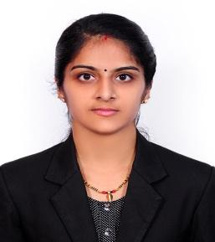
PRAVEENA
Email: PRAVEENA.362031@2freemail.com

OBJECTIVE
To build a career by joining a world-class organization which provides opportunities to utilize all my abilities and enhance my knowledge and skills that would contribute towards growth of the organization along with my own professional growth.
PROFESSIONAL SUMMARY
Having a pleasing personality and very good interpersonal skills, energetic, young, dedicated, self motivated and a through approach to working own initiative, ability to adapt to new environment and grasp work quickly.
EDUCATIONAL QUALIFICATION
- IATA travel and tourism -“Speedwings aviation academy”
- MBA human resource management –“ Bharathiar university”
- Bachelor of science –“Bharathiar university”-computer science
- HSC- Kerala state board
- SSLC- Kerala state board
COMPUTER KNOWLEDGE:
MS office
Operating systems: Windows, Linux
Capable of working with a good typing speed.
CURRENT EMPLOYER
✓ Organization: API MIDDLE EAST FZE (Sumitomo corp. Joint venture)
✓ Designation: Admin & Finance Executive
✓ Duration: October 2015 – Present

❖ JOB DESCRIPTION

- Organize office operations and procedures
- Analyzes the attendance and regularity of employees in the organization
- Maintain all databases including financial and staff report
- Meet staff requirements, needs and resolve their problems, support to HR Department
- Ticket bookings and Amendments
- LPO preparation for issuance of ticket
- Preparation of Travel itinerary
- Hotel bookings
- Process accounts payable cheques
- Post and maintain accounting documents in the database
- Ensure invoice payments
- Handle petty cash allocation and transactions.
- Chase overdue invoices by telephone, email & letter within agreed timescales.
- Send out monthly client statements/letters as may be agreed from time to time.
- Other duties as delegated from time to time by the Accounts Manager or Finance Manager or any other person designated in their absence.

PERSONAL DETAILS
Date of birth: 02/10/1989
Visa: Spouse Visa
Gender: Female
Marital status: Married
Languages known: English, Hindi, Tamil, Kannada & Malayalam
Hobbies: Music, Drawing, Travelling
Strengths: Friendly with people, helping others, motivating, self-confident
DECLARATION
I hereby declare that all statements made in this application are true and correct to the best of my knowledge and belief.
Sincerely,

:

