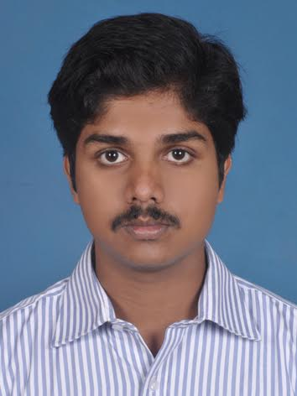

BINOY
Any suitable job
BINOY.362034@2freemail.com
Visa Status: VISIT VISA
(Availability: Immediate)

CAREER OBJECTIVE

To be an integral part of the growth oriented organization and work in a challenging anddynamic environment. To contribute to the development of the organization which I represent and serve while concurrently upgrading my skills knowledge.

EDUCATIONAL DETAILS
- Diploma in Nautical science
- HSE
- SSLC
JOB RESPONSIBILITIES

- answer phones and transfer to the appropriate staff member
- take and distribute accurate messages
- greet public and clients and direct them to the correct staff member
- coordinate messenger and courier service
- receive, sort and distribute incoming mail
- monitor incoming emails and answer or forward as required
- prepare outgoing mail for distribution
- maintain office filing and storage systems
- update and maintain databases such as mailing lists, contact lists and client information
- retrieve information when requested
- update and maintain internal staff contact lists
- co-ordinate and maintain staff administrative records such as staff parking, staff phones and company credit cards
- type documents, reports and correspondence
- organize travel arrangements for staff
- co-ordinate and organize appointments and meetings
- assist with event planning and implementation
- monitor and maintain office supplies
- ensure office equipment is properly maintained and serviced
- perform work related errands as requested such as going to the post office and bank

PROFESSIONAL EXPERIENCE
KALYAN JEWELLERS INDIA.PVT.LTD

Oct 2015 to Feb 2017
Supervisor

TECHANICAL SKILLS
- Certified in MS office, MS word, Data entry,Internet &Email, Networking
LANGUAGE KNOWN:
- English, Hindi, Malayalam and Tamil

Personal Details:

- Date of Birth : 21 june 1993
- Nationality : Indian
- Marital Status : Single
- Visa Status : Visit Visa
DECLARATION:
I hereby declare that the above mentioned information is true to the best of my knowledge.

Place: DUBAI Regards
Date

