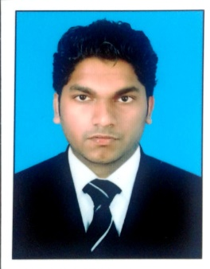
Akhil
Receptionist,
Hamdan Bin Mohammed Smart University
Dubai, united Arab Emirates

akhil.362068@2freemail.com

Dear Sir,

I am writing to enquire if you have any opening for me to work with your successive team. I enclose my CV for your information as you can see, I have had extensive vacation work experience in office environments, the retail sector and service industries, giving me varied skills and the ability to work with many different types of people. I believe I could fit easily into your team.

I am a conscientious person who works hard and pays attention to detail. I'm flexible, quick to pick up new skills and eager to learn from others. I also have lots of ideas and enthusiasm. I'm keen to work for a company with a great reputation and high profile like yours.

I have excellent references and would be delighted to discuss any possible vacancy with you at your convenience. In case you do not have any suitable openings at the moment, I would be grateful if you would keep my CV on file for any future possibilities.

Yours sincerely,

Akhil

Summary of Qualifications
- Strong communication and customer service skills.
- Excellent planning and organization skills.
- Ability to deliver a good customer service experience.
- Familiarity with computers and ability to type 30 words per minute.
- Maintain observer’s honesty and loyalty.
- Strong ability to listen and respond effectively to repetitive questions.
- In-depth knowledge of providing passengers with general travel information.
- Proficiency in Microsoft Office (Outlook, Excel and Word)
Work Experiences

- Passenger Service Agent
Cochin International Airport Limited (CIAL) Kerala, India
- Assisted customers before and after a flight.
- Provided the needs and requirements of passengers and airport personnel.
- Handled baggage claims, check rider reservation.
- Assisted passengers with special needs.
- Provided supports for other airport personnel including pilots and engineers.
- Helped the airline staff members for safe and consistent operations.

- Customer Service Agent
Dubai Metro Dubai, UAE
- Answered customer’s questions and provided assistance based on each customer’s need by brand in friendly, helpful and prompt manner.
- Provided all customers assistance with directions, maps and local information and appropriate service information.
- Attended complaints and enquiries regarding ticket.
- Introduced features of different types of card to first time travelers.
- Assisted passengers to purchase tickets through TVM (Ticket Vending Machine) Based on the zone.
- Helped passengers to get on and off the train safely during rush hours

- Travel Agent

Galaxy Travels Kerala, India

- Made reservations, prepared and issued tickets and journey, calculation of fares and issued refunds.
- Attended internal and external calls and emails regarding flights status
- Worked well to achieve targets and ensured that all queue and updates regularly checked.
- Monitored and communicated airline schedule changes and flight cancellations.

Educational Qualification

- Diploma in Travel and Tourism,
Syscoms Institute, Dubai
- 10th standard
Board of Examination in Kerala
- 12th Standard
Examination under the board of higher secondary
- Currently Pursuing a Degree
BBA in Business Mathematics, Kannur University, School of Distance Education, Kerala

Computer and Equipment Skills
- Ms Word and Excel.
- Skills in reservation software.
- CTRs and keyboard for passenger processing.
- Ticket and baggage tag printing equipment.
- Internet skills.

Attended Training
- Customer service Training (Dubai Metro, Serco)
- Airport Customer Service training (syscom institute, Dubai)
- Airline ticket reservation training (Sabre, Galileo, Amadeus etc.)
- Conflict management Training (Dubai Metro, Serco)

Personal Details
- Name = Akhil
- Nationality = Indian
- Sex = Male
- Marital Status = Single
- Date of Birth = 25/04/1990
- Age = 26
- Language known = English, Hindi, Malayalam, Tamil

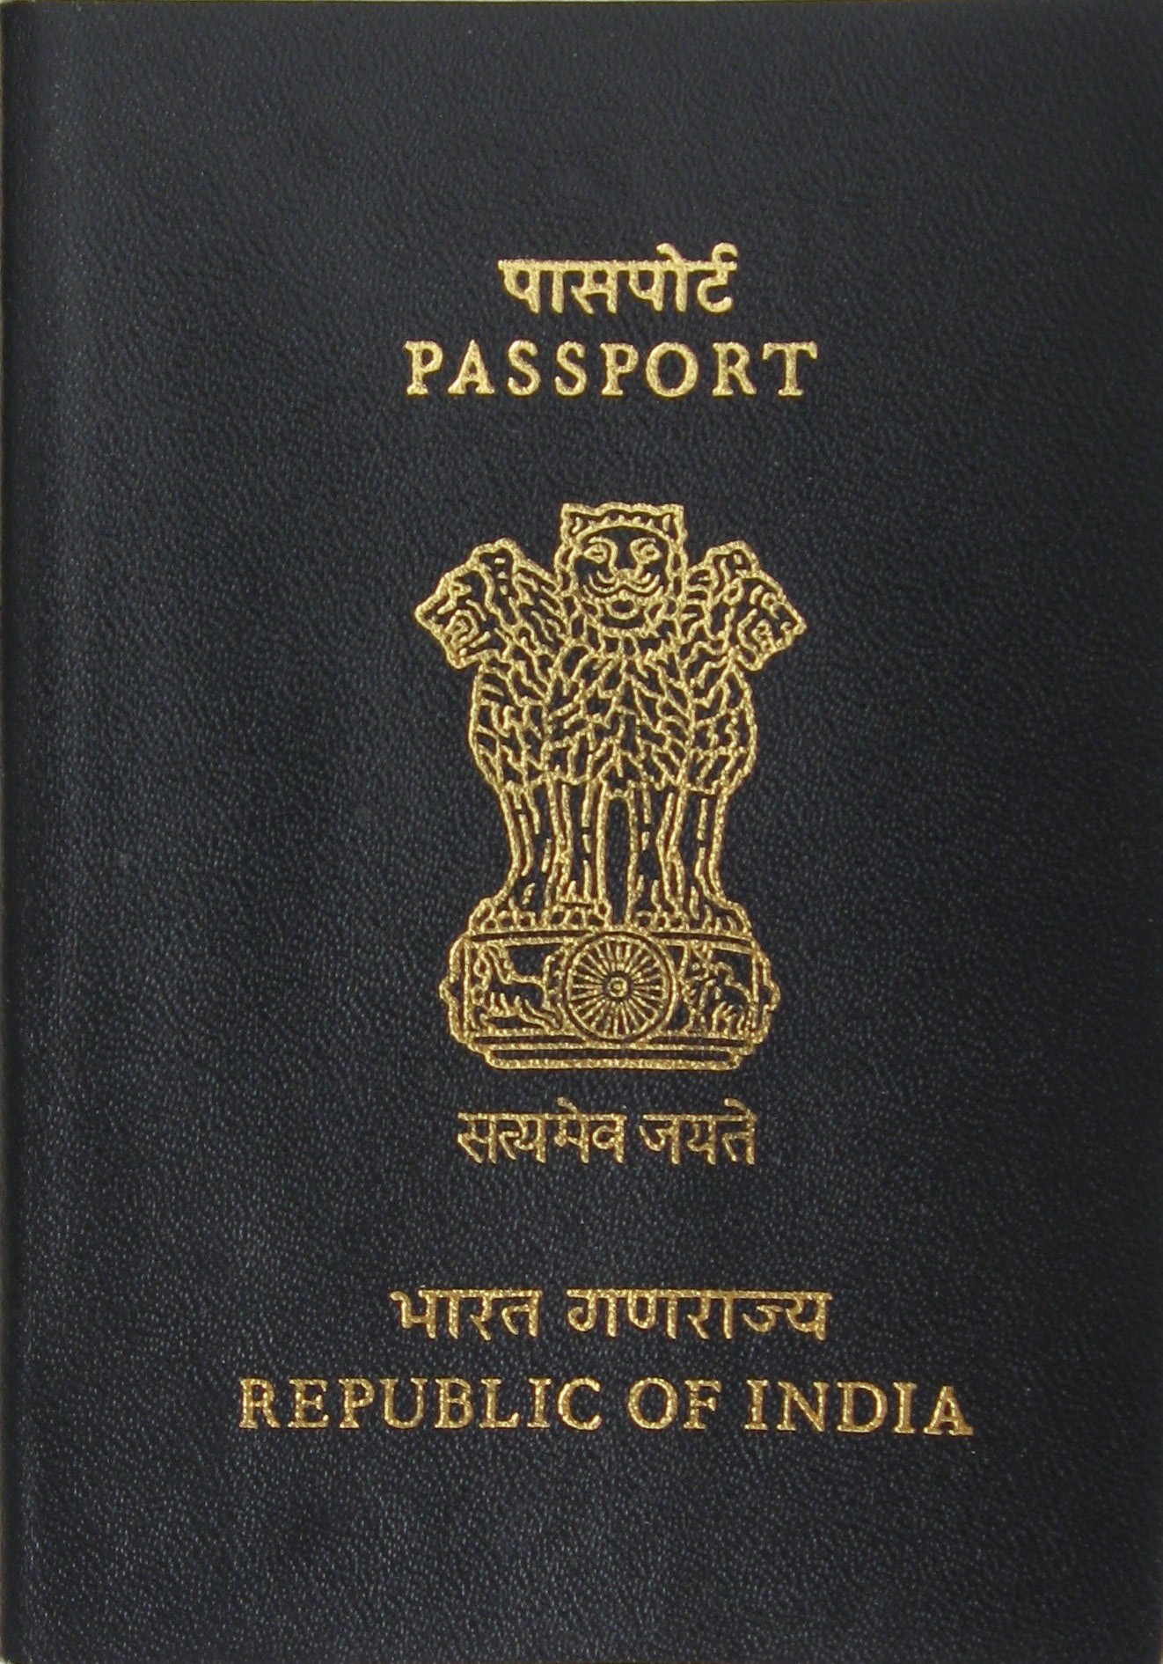 Passport Details
- Date of Issue = 31/12/2009
- Date of Expire =30/12/2019
- Place of Issue = Kozhikode, India
- Visa Status = Residence Visa

Declaration
I hereby certify that the above details are true and correct according to the best of my knowledge & experience. If I selected I assure that I would perform to the best of my abilities, early awaiting a positive response.

AKHIL

