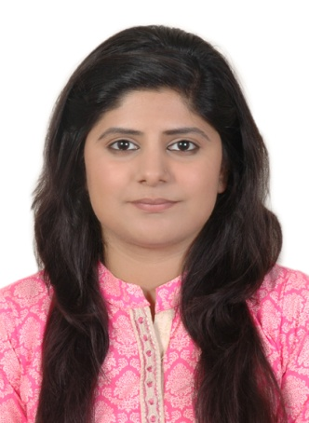

SAFA
Email: SAFA.362122@2freemail.com

Objective:
“Looking for a career in a reputable organization where long term career opportunities are provided where I can exploit best of my potential in customer service Industry and manage challenges in such a manner that it translates achieving a personal and organizational growth”

Academic Qualification:

- Bachelors Of Arts (B.A) 2014 from University Of Karachi.
Experiences:

Designation: Travel Consultant
Working as Travel Consultant In Qeshm Travels And Tours L.L.C (Dubai) From 28 Jun 2016.
- Research various destinations and means of travel regarding price, customs, weather conditions reviews.
- Diagnose the client’s specification and desires and suggest suitable travel package or services.
- Collect deposits and balances.
- Create and update electronic records of clients.
- Maintain relationship with key person.
- Reach the revenue and profit targets.
- Keep financial statements and documents.

Designation: Administration Officer
Hotel Faran Worked as Office Admin .From 5th September 2014 till 20th April 2015.
Responsible for the day-to-day general administration of the organization, assisting the Chief Executive and supporting the staff team.
Act as the main point of contact for visitors and callers, including reception duties. Provide general administrative support to the Chief Executive and staff team. Provide support for the arts program/projects including assisting with administration of project work where appropriate and when agreed.

Principle Accountabilities
- General word processing.
- Filing, copying and faxing.
- Collation and distribution of minutes, reports and other documents.
- Dealing with incoming and outgoing mail and general emails.
- Ordering of equipment, materials and office supplies.
- Minute taking for Board, team meetings and other meetings as required.
- Undertake and assist in the recording and processing of invoices, receipts and payments as required and instructed.
- Administer the petty cash system and ensure appropriate record keeping.
- Arrange hospitality, purchase supplies to ensure the smooth running of the organization on a day to day and as required basis.
- Maintain the central filing system, general database and archive.

Position Summary:
To help people plan, choose and arrange their holiday. Usually work to a budget, set out by whoever is planning the holiday. Also offer advice and opinions on where to go and local tourist attractions, events and customs.

Al Asad Travels And Tourism Pvt Ltd Worked as Counter Assistant from 1st May 2015 to 20th April 2016.

Principle Accountabilities
- Collect payment for transportation and accommodations from customer.
- Converse with customer to determine destination, mode of transportation, travel dates, financial considerations, and accommodations required.
- Compute cost of travel and accommodations, using calculator, computer, carrier tariff books, and hotel rate books, or quote package tour's costs.
- Book transportation and hotel reservations, using computer terminal or telephone.
- Plan, describe, arrange, and sell itinerary tour packages and promotional travel incentives offered by various travel carriers.
- Provide customer with brochures and publications containing travel information, such as local customs, points of interest, or foreign country regulations.
- Print or request transportation carrier tickets, using computer printer system or system link to travel carrier.

Al Asad Travels And Tourism Pvt Ltd Worked as Umrah Assistant Seasonally.

Principle Accountabilities
- Facilitates attestation of Umrah agreement from Ministry Of Foreign Affairs (MOFA)
- Submit passports to the Travel Agent Association of Pakistan (TAAP) for Umrah visa stamping
- Stays connected with airline representatives to get timely updates with airline deals, offers and promotions.
- Promote ticketing business Umrah packages and products through variety of mediums.
- Resolves customers queries related to services rendered.

CERTIFICATE OF ACHIEVEMENTS:

- Galileo core course & Galileo global affairs from Travel port
- Air ticketing & tariff basic course from silver wings academy Karachi, Pakistan.
- Reservation of ticket
- Cancellation of ticket.
- Calculation of fares according to the destination.
- Baggage allowance.
- Country codes.
- Airline Codes.

PERSONAL DETAILS:

- Date of birth : 20 December 1992
- Nationality : Pakistani
- Marital status : Single
- Language known : English and Urdu
- Place Of Birth : Abu Dhabi

Reference:
Will be furnished up on your request.

