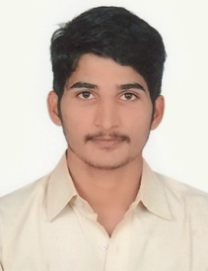
Avinash
Avinash.362127@2freemail.com

Career Objectives:
Seeking a challenging assignment in Customer Relations and grooming a career to become an important
asset of strategic management group
An effective communicator with strong analytical & problem solving abilities
Posses a detail oriented attitude for completing any task entrusted
ACADEMICS:
B.C.A. (Punjab Technical University )
S.S.C (UP Board )
H.S.C (UP Board)

Experience:

KAYPEE MECHANICAL INDIA PVT.LTD
Duration : 25/07/2012 TO 20/10/2015
Job profile : Admin.Computer Operator
KEY SKILLS AND COMPETENCIES
- Knowledge and experience in using computer systems.
- Communicating effectively and professionally.
- Can work at a sustained pace and produce quality work.
- Updating of customer information in paper records and on computer databases
- Receiving store deliveries.
- Representing the store in a professional and positive manner.
- Creating and maintaining long-term relationships with regular customers.
- Assisting in all store administrative tasks.
- Taking care of the customers’ needs while following company procedures.]
COMPUTER PROFICIENCY:
Operating System :Dos, Windows Xp,Windows7,Windows8.
- Web Applications.
- Database (Oracle 10g).
- Microsoft office.
- Computer Hardware/Software.
- Internet Browsing
- E-mail,outlook .
- Formatting & Installation .
- Recovery Maintenance System.
EXTRA CURRICULAR:
Regular participation in various games in high school competition
Actively participated in blood donation
Traveling, listening and singing music’s

