CURRICULUM VITTAE
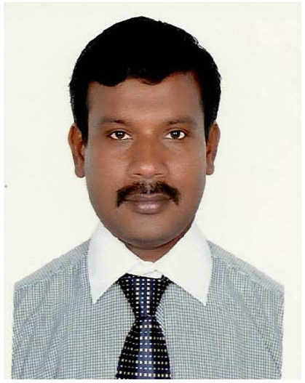
E mail Id : shaikfareed.362133@2freemail.com

Objective

To seek a responsible and challenging position within a reputed organization in the field of administration secretarial/public relation/customer service/travel and tourism and invest all my professional skills, qualification, valuable experience to the optimum level, to facilitate continued career growth and to produce best results for the organization.

Experiences:-
Working as Public Relation officer ,AMREET INDUSTRIES FZE, Sep 2015 to till date.

Worked as Public Relation officer and Shipping Clearance ROYAL GULF SHIPPING at Dubai March 2012 to 2013 Jul.

My responsibilities include:

- All consulate works

- All Immigration / Labor office Works related to Employer / Employees, New / Renewal of Visas and Residencies and Trade License,
- Chamber of Commerce Certificate, Preparation/Arranging Civil Defense / Police Directorate formalities,
- All type of Visa Formalities, Medical Arrangements, Car Registration Formalities, Driving License Formalities and Leave Records, Transportation arrangements
- And Accommodation formalities of Delegates.

Feb2006 to 2012 worked as ALLURE INTERNATIONAL AEROSOLS LLC in Dubai as PRO

Working in Public Relations in M/S. ALLURE INTERNATIONAL AEROSOLS LLC from December 2006 From 2012 Assist Public Relation officer.
My responsibilities include:

- All consulate works

- All Immigration / Labor office Works related to Employer / Employees, New / Renewal of Visas and Residencies and Trade License,
- Chamber of Commerce Certificate, Preparation/Arranging/ Police Directorate formalities,
- All type of Visa Formalities, Medical Arrangements, Car Registration Formalities, Driving License Formalities and Leave Records, Transportation arrangements
- And Accommodation formalities of Delegates.
- Assisting the Public Relation Officer and Personnel Officer on all issues.

Port Clearances:
- Jebel Ali Free Zone Export & Import clearance
- Cargo Village Clearance
- Saif Zone clearance- Sharjah
- Sharjah freight center
- Hamriya Port clearance

Feb 2005 to 2006 worked as VSA (Bcn middle east ) in Dubai as asset PRO

Worked as Public Relation officer for 2 years in Bcn Middle East, Dubai.
My responsibilities were:

- Preparation of Visa / Labor Card New / Renewal Application, Collecting Tender Forms from the relevant Departments, Responsibilities.
- Medical arrangements & Vehicle Registration formalities, Vacancy advertisements,
- Medical, & Leave Records, Travel Arrangements & Car Hire & Car Registration Formalities, Leave and Final Settlement Calculations, Driving License &Vehicle Maintenance Formalities.

2000 to 2004 date working as Merchandiser for Swiss Arabian Perfume in Abu Dhabi
- Products Show arrangements in Malls
- Designing and Shifting Products for Shows and for Adds
- Getting permission from related authority to arrange stalls in malls

Area of Interest to work:

- All Taa”sheel works
- To Handle end to end PRO matters for a company
- To obtain Labor approvals, Quota approvals, arrange Visa stamping and labor contracts for all new employees being hired in company.
- To arrange for various statutory documentation such as Labor Card, Emirates ID Card for all employees.
- To have close interaction with various works related to all govt bodies such as RTA, Police, Municipality, Economic Department, DEWA, Etisalat etc from time to time regarding company’s issues.

Educational Qualifications:
Standards | Institution Name | Place of Institution | Year
SSLC | Govt.High School | Muthupet, India | 1991
Higher secondary level | Govt High School | Muthupet,India | 1993
B.A History | Annamalai University | Chidambaram, India | 1996

Additional Skills:

- Light Vehicle Driving- License (Manual) in United Arab Emirates (Abu Dhabi-2004)
- Well versed in the process of legal documents in UAE
- Internet Browsing

Language known:

- English
- Hindi
- Malayalam
- Arabic
- Tamil

Advance Updates:

- Handling telephones and faxes,
- Preparing letters and documents using MS Office word and Excel

Personal details:
Nationality : Indian
Date of Birth : 12.02.1978
Religion : Muslim
Visa Status : Employment Visa

I have a total 15 years of full-time work experience in UAE in Documentation control and in Public Relations(PRO), I believe that the skills I have acquired in the course of my professional experiences will be valuable assets for your organization.

I do hereby declare that the information furnished above is true to the best of my knowledge and belief.
Your’s

