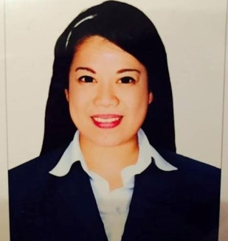
Rica
Rica.362164@2freemail.com

Visa Status: Resident (transferrable)

Career Objective:
A confident, highly resourceful and reliableBachelor of Arts Degree, who is seeking for challenging job utilizing my education, a position where I can be at my best and help the company meets its goal and expectation.
Work Experience:
Local Store Marketing Representative-Customer Care
November 2014 – May 20,2017 Last Day (end of contract)
McDonalds Food Corporation (emirates fastfood llc)
Abu Dhabi
- Proven ability to answer customer’s questions and give information regarding the businessprocedures and policies in an exact and customer-friendly way.
- Doing Customer Relations, new promotions, functions and party needs
- Efficient food and beverage services to the guests.
- Attend and respond to guests’ needs promptly and professionally.
- Undertakes Clerical duties such as reports, daily inventories, sales, targets and guest count.

Quality Control Personnel
December 20, 2013 – October 16, 2014
Liwayway Marketing Corporation
Manila, PH
- Approves finished products by confirming specifications; conducting visual and measurement tests; returning products for re-work; confirming re-work
- Documents inspection results by completing reports and logs.

Administrative Assistant
November 28, 2012- November 16, 2013
Manila Electric Company
Manila, PH
- Resolves administrative problems by coordinating preparation of reports, analyzing data, and identifying solutions.
- Provides information by answering questions and requests..
- Completes operational requirements by scheduling and assigning administrative projects; expediting work results.

Educational Background:
- Tertiary
(B.A) Bachelor of Arts in Communication
National College of Science and Technology
Aguinaldo Hi-way Amafel Bldg. Dasmarinas Cavite PH.
June 8,2008 – March 28,2012

Qualifications and Skills:
- Goal driven
- Above average oral and written communication skills both in English and Filipino and basic Arabic.
- Good communication skill and personality.
- Ability to listen analytically and act accordingly.
- Pleasing personality to interact with customers enthusiastically.
- Flexible and quick learner.
- Dedicated and hard worker.
- Able to handle customer complaints effectively.
- Ability to work under pressure with minimum supervision.
- Computer Literate (Microsoft office, Internet Browsing)

Personal Information:
Citizenship : Philippines
Date of Birth : 31/10/1989
Weight : 60kg
Height : 5’2ft
Gender : Female
Marital Status : Separated
Religion : Roman Catholic

DECLARATION:

I hereby certify that the above information is correct and true to the best of my knowledge and beliefs.

