Curriclum Vitae of

USMAN

USMAN.362170@2freemail.com 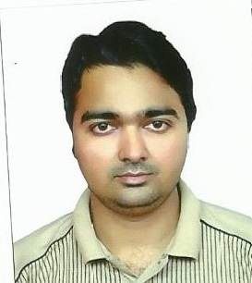

Objective:-

I am highly motivated, enthusiastic and competent person have excellent ability to

work calmly and very efficiently under pressure

I am looking to obtain a position that will allow me to utilize my strong Professional

skills, education background, and ability to work well with people
I am also looking to secure a promising position that offers both challenge and good opportunity for growth.

Honesty and Hard working are my principle pillare by which I want to develop my career.

EDUCATION QUALIFICATION:-
- (S.S.C) Board of Intermediate and secondary Education Gujranwala
- (DAE .civil) Diploma of Accociate Engineer
- Govt College of Technology Rasul Mandi Bahuddin

COMPUTER SKILLS:-

- Auto Cad (2d & 3d)
- Microsoft office… World . Exal
- Accontant softwere (E-store)
- Computer Hardwere

Personal information:-

- Date of Birth : 04/03/1987

- Nationality : Pakistani

- Religion : Islam

- Marital Status : : Unmarried

- Visa Exp : 28/10/2016

WORKING EXPRANCE:-

- 1 Year work in ABDUL MAJEED CONTRACTING ( OMAN) As a site fourman
- Still working in RAS AL AIN BLDG MAT TR (sharjah .UAE)
- As a accountant(28/10/2014 to 28/10/2016)

LANGUAGES:-

- Urdu
- Arabic
- English
- Punjabi

ABILITES:-
- Adapt easily to new concept and responsibilities.
- Self motivated and goal oriented.
- Mature patient and calm personality

