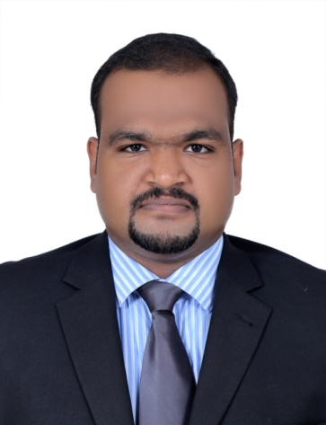  AJMAL  DETAILS  Ajmal.362182@2freemail.com  ABOUT ME  Experienced Process Associate with a demonstrated history of working in the airlines/aviation and Internet marketing industry. Skilled in Airlines, Airports, Customer Service and Leadership. Strong professional with a Master of Business Administration (M.B.A.) focused in Airline and Airport Management from Bharathiar University.  SKILLS  MS Office ●●●●●●●●●●  Online Stock Trading ●●●●●  Customer Service ●●●●●●●●●●  Leadership ●●●●●●●  Sales ●●●●●●●●  02/03/2017 |  | EXPERIENCE  PROCESS ASSOCIATE – HUERAY TECHNOLOGIES PVT. LTD – TECHNOPARK  Trivandrum, Kerala — SEP 2015-MAR2017  Company Profile:  Hueray Technologies brings together advanced technology, robust infrastructure, and a large pool of proven talent to provide a wide range of IT services to Services around the world, cost-effectively and seamlessly. We are based on a creative, intelligent approach to the integration of technologies and business processes that requirements. Hueray Technologies has been delivering Product Engineering Services and technology-driven Business Solutions that meet the strategic objectives of careers by leveraging our domain and business expertise and partnerships and alliances with leading technology providers.  Responsibilities:  Contacting the customer over the phone to sell the product, providing technical support and achieve the goal. Assisting them through chat and email and providing solutions for the issues they are facing, analyzing the client’s website to check for errors and warnings and creating analysis report with correct solutions and action plans to overcome the problems. Promotion of the website and related advertisements of the clients.  Passenger service agent – celebinas airport services india pvt. ltd – chhatrapati shivaji international airport  Mumbai, Maharashtra — SEP 2013-JAN 2015  Company Profile:  Celebi Nas Airport Services India Pvt. Ltd. provides a host of innovative services to its customers ranging right from Ground Handling and Cargo services to commercial services like lounges, Meet and Assit and more, committed completely to the smooth, safe and efficient delivery of prime services to achieve maximum customer satisfaction.  Responsibilities:  Check-in of passengers, mishandled baggage services, arrival meeting of flight, managing boarding procedures, pre flight and post flight activities, preparation of post flight reports, immigration consultation of passenger, preparation of monthly station reports, supervision of flights, achievement of airline goals by on-time flight performance.  EDUCATION  post graduation  Bharathiar University, Coimbatore, Tamil Nadu — 2012-2015  Obtained Master of Business Administration specialized in Airline and Airport Management with Aimfill International, Trivandrum.  Diploma  Aimfill International, Trivandrum, Kerala — 2012-2013  Completed Diploma course in Airline and Airport Management, Ground Handling, Airline Ticketing and Travel Management, Hospitality management and Customer Service.  graduation  Kerala University, Trivandrum, Kerala — 2009-2012  Completed Bachelor of Commerce(B.Com) with Taxation, Law and Accounts with St.Xavier’s College, Tumba, Trivandrum.  ADDITIONAL SKILLS AND TRAINING  - CERTIFICATE COURSE IN CAPITAL MARKET(2011)  - DGR/Ramp Safety/Fire safety conducted by Celebi Nas & British Airways, (License No BOM )  - Basic knowledge of online stock Trading.  - C certificate holder from NCC.  - Google Adwords Shopping Certification(Valid till February 2018)  - Google Analytics Certification(Valid till August 2018)  - Microsoft Bing Ads Certification(Valid from February 2017)  PERSONAL DETAILS  Date of Birth : 22nd November 1991  Gender : Male  Nationality :Indian  Marital Status : Married  Languages Known : Malayalam, English, Hindi  REFERENCES : Available on Request  DECLARATION:  I hereby declare that all statements made herein above are true, Complete and correct and not false or misleading.

