SANTHOSH

Senior level professional – Project controls, planning & Business Development

A result-oriented professional with over 15 years of experience
Successfully managed multiple projects, ensuring it complied with all cost and scope specifications
Expertise in all aspects of project control & planning , review of commercial terms and conditions; interpreting contractual obligations &
rights; evaluating technical specifications
Expertise in steering the successful rollout of projects with accountability of defining scope, setting timelines, analyzing
requirements, prioritizing tasks and identifying dependencies as per pre-set budgets
A strategic planner with expertise in planning and executing construction projects with a flair for adopting modern construction
methodologies; complying with quality standards
Exhibited excellence in:
• Executing the entire project right from scratch to its completion
• Ensuring compliance with organization, client’s & legal requirements
A strategist cum implementer with recognized proficiency in spearheading business to accomplish corporate plans and goals successfully
Santhosh.362186@2freemail.com

Key Skills

Career Timeline

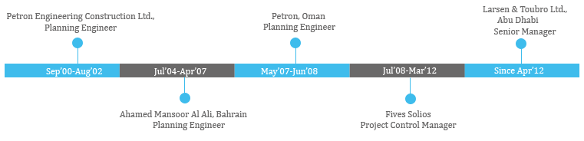

Education
IT Skills

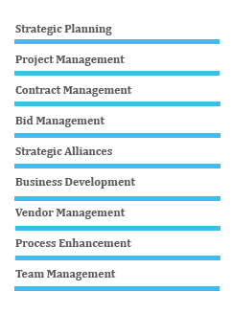

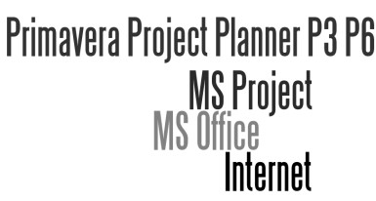B-Tech in Mechanical Engineering from
University of Calicut-(1996-2000)

Notable
Accomplishments

Organizational
Experience

Since Apr’12

Previous Experience

Jul’08-Mar’12

May’07-Jun’08

Jul’04-Apr’07

Sep’00-Jun’04

Personal Details

• Managed high net-worth projects worth US$ 120 Million involving an esteemed set of clientele including BECHTEL,SNC LAVALIN,HYDRO,SIEMENS
• Successfully handled the project control & planning functions of EPC projects like EGA smelter & refinery expansion, Maáden Aluminium smelter, Qatar Aluminium Smelter, Sohar Aluminium Smelter, Alba line
5 expansion, Hidd power plant, Indian Oil corporation project
• Successfully delivered pre-qualifications, Request for Proposals (RFP’s)
for over 10 projects in last 2 years and won 2 out of them.
• Played a key role in adding new revenue streams by business development initiatives
• Received appreciation from clients like SNC LAVALIN,BECHTEL for executing various Aluminium Smelter projects

Larsen & Toubro Ltd. (Metallurgical & Material Handling IC), Sharjah as Senior Manager- Project Controls & Business development
Key Result Areas:
• Developing project baselines; monitoring & controlling projects with respect to cost, resource deployment and quality compliance to ensure satisfactory execution of projects using Earned value concepts.
• Leading a team of professionals; ensuring timely submission of schedules and ensuring suitable deployment and timely availability of
manpower during execution stage.
• Managing the bidding process and business development activities
• Preparing & recommending procurement plans / bidding strategies to best suit project plan
• Liaising with clients, architects, consultants, contractors, sub contractors & external agencies for determining technical specifications,
approvals and obtaining statutory clearances

Fives Solios
Joined as Planning & Contracts Engineer & rose to Project Control Manager

Petron, Oman as Planning Engineer

Ahamed Mansoor Al Ali, Bahrain as Planning Engineer

Petron Engineering Construction Ltd., India as Planning Engineer

Date of Birth: 1st August 1977
Marital Status: Married
Nationality: Indian
Driving License Details: Issued at UAE. Valid up to 29’03’24) Languages Known: English, Hindi, & Malayalam
No. of Dependents: 01
Visa Status: Resident

Larsen & Toubro Ltd(Metallurgical & Material Handling IC) Client: EGA (Emirates Global Aluminium) Project: Aluminium Smelter
Period: Apr’12-Dec’13
Consultant: SNC Lavalin
Role: Senior Manager- Project Controls & Business development

Client: EGA (Emirates Global Aluminium) Project: Aluminium refinery
Period: Jan’14-Aug16
Consultant: Bechtel
Role: Senior Manager- Project Controls & Business development

Fives Solios
Client: MA’ADEN (Saudi Arabian Mining Company)
Project: Aluminium Smelter
Period: Jan’11-Mar’12
Consultant: Bechtel
Role: Planning & Project Control Manager

Client: Qatar Aluminium
Period: Jul’08-Oct’10
Consultant: Hydro
Role: Planning & Contracts Engineer

Petron, Oman
Client: Sohar Aluminium Smelter
Period: May’07-Jun’08
Consultant: Bechtel
Role: Planning Engineer

Ahamed Mansoor Al Ali, Bahrain
Client: Sohar Aluminium Smelter
Period: May’06-Apr’07
Consultant: Bechtel
Role: Planning Engineer

Client: AL Ezzel, Bahrain Project: Power Project Period: Feb’05-Apr’06
Consultant: Siemens/Tractabel Ltd., Role: Planning Engineer

Client: Alba, Bahrain
Project: Alba Line 5 Expansion Project
Period: Jul’04-Jan’05
Consultant: Bechtel
Role: Planning Engineer

Petron Engineering Construction Ltd., India
Client: Indian Oil Corporation Ltd., Bihar
Project: FCCU & DHDT Period: Sep’00-Jun’04
Consultant: Samsung
Role: Planning Engineer

