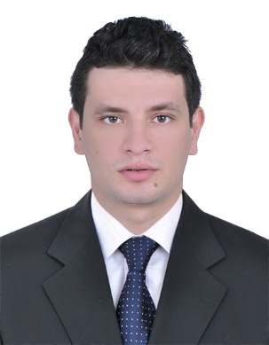
Abd
Abd.362209@2freemail.com
OBJECTIVE
I am a responsible, diligent and honest worker, interested in using my expertise to the full within an environment, which allows me to further my existing skills and knowledge. I have a wealth of experience both academic and work related, which has been imperative to acquiring the necessary communication and teamwork skills required for a successful career. My outgoing nature and creativity have also allowed me to implement change and build relationships between departments in my current role. I feel it is time for new challenges and hope to immerse myself in a career I can work within for the rest of my professional life.
EDUCATION:
- Bachelor degree of low – Cairo University, Giza (Egypt) 2015.
Language:
- Arabic: Mother tongue.
- English Language: Good command, written & spoken
SKILLS:
Computer Skills:
- Excellent knowledge of MS Windows (All Versions).
- Excellent Microsoft Word & Excel.
- Proficient Internet User Skills.

Communication Skills:
- Problem solver.
- Team Player.
- Hard Worker.
- Self-Motivated, Strong Analytical Ability.
- Work Effectively With Divers Group Of People, Highly Trainable & Fast Leaner.

WORK EXPERIENCE

January 01, 2017 – March 30th , 2017 : TE-Data, Cairo (Egypt) "Quality Assurance Specialist "
- Listen calls for Agents and measure if it pass or fail
- Monitor Customer satisfaction
- Reporting daily , Monthly and yearly what's the gaps in work and try to get another process aligned to company
April. 01, 2016- January 01, 2017 : TE-Data, Cairo (Egypt) “Reseller & Corporate Billing Control agent”.
- Perform financial validation upon customer activation (support documents, hardware fees paid, information provided adequate) or customer status update such as upgrade or downgrade to ensure validity and adequacy of information.
- Review, verify and validate test bill cycle run according to a predefined sampling method and focus on new customers and customers with updated status ensure accuracy of results.
- Monitor paid and unpaid invoices/Performa’s, visit customers when needed to explain due balances and work to reduce re-sellers and corporate due amounts to increase collections and cash flow.
- Use predefined policies and procedures to handle and resolve disputes / queries with customers, warn customers in cases of delays, suspend accounts after the grace period if invoices not paid after receiving approvals, void invoices where necessary, adjust debit and credit notes to ensure business flow
- Forward information where necessary to relevant departments such as IT or sales to facilitate resolution of customer queries within set guidelines
- When disputes are not resolved, deal with appropriate other entities such as sales and legal to solve disputes the most appropriate way.
- Archive documentation related to billing and collection control
- Generate reports describing tickets issues compared to predefined SLA’s to show evidences during discussions / develop external balance sheets to clarify due balances and agree on conclusions
- Prepare monthly reports representing the voided invoices during the previous month to track and document all activities appropriately

Augast 01, 2015 – April 01 , 2016 TE-Data, Cairo (Egypt) " call center Agent "
- Has ability to handle native and forigen customer
- Has ability to handle angry customer
- Handling calls with high performance
May 01,2015 – Augast 01,2015 Ahli United bank in Egypt "Sales for credit cards "

While studying trained at offices of a lowyer as a summer trainning summer 2012 ,2013, 2014 and 2015
- I have experience collect and record the cases
- I have experience to identify the hearings
- I have experience to receive and hand over the recorders
- I have experience to record and appeal the cases

Personal Information:
- Date of Birth: 08-09-1993.
- Marital Status: Single.
- Military Status: Exempted.

