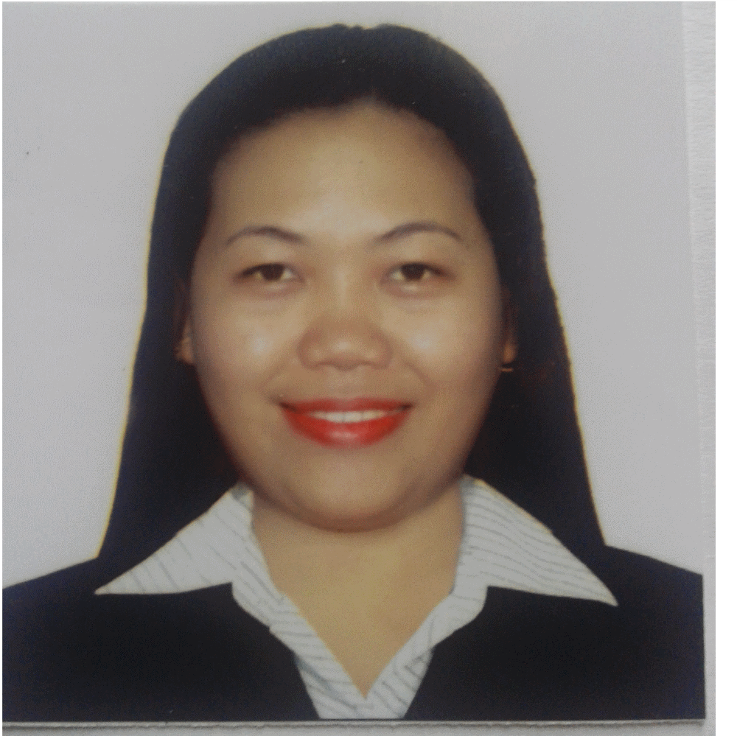

Brenda
Brenda.362216@2freemail.com

Personal Detail:

Age: 31
Birth Date: 12/11/1984
Status: Single
Religion: Catholic
Language: English and Tagalog

Objectives:

To obtain a position that will enable me to use my strong organizational skills, educational background and ability to work with other people.
To get suitable job where I will get an opportunity to enhance my abilities in communication and interpersonal skills. To employ my knowledge and experience with the intension of securing of professional career.

Qualification:

Im filled a type of person filled with enthusiasm and devoted in my work, hardworking, and willing to execute my knowledge in this filled, willing to be trained, kind , honest, and friendly. And base on my learning experience I’m computer literate person.

Working Experience:

Advanced Facilities Management
Housekeeping Attendant cum Coordinator
United Arab Emirates
SY: 2015 to present

Job Description:

Supervise work activities of cleaning personnel to ensure clean, Assign duties, inspect work, and investigate complaints regarding housekeeping service and equipment and take corrective action. May purchase housekeeping supplies and equipment, train new employees, and recommend dismissals.

- Clean rooms, lounges, lobbies, bathrooms and hallways
- Vacuum and wash the carpets and rugs
- Empty wastepaper baskets and ashtrays
- Transport trash to waste disposal equipment
- Dust and polish wooden surface and furniture
- Replenish bathroom and mini bar supplies

Gulf Compass Services
Secretary cum Receptionist
Riffa, Bahrain
SY: 2013-2015

Job Description:
- Perform secretarial duties
- Composes or transact application through online application
- Compiles files and documents of the office as well
- Greet the customers and visitors in manners ways
- Talk to the customer base on their problem
- Make a report by using MS WORD and Excel
- Answer the telephone to provide the information
- Making quotation and doing invoices

Medceetech Company
Sales Representative
Manila, Philippines
SY: 2011-2013

Job Description:
- Encourage the client to buy a product
- Conduct the product knowledge to the clients
- Be more competitive
- Introduce that the product is well known.

Educational Background:

College: Laguna State Polytechnic University
Sta. Cruz, Philippines
SY: 2008-2011

Course: Bachelor of Science Business Administration
Major in Management

Secondary: St. Thomas Academy
Sto. Tomas, Philippines
SY: 2000-2001

