CURRICULUM VITAE  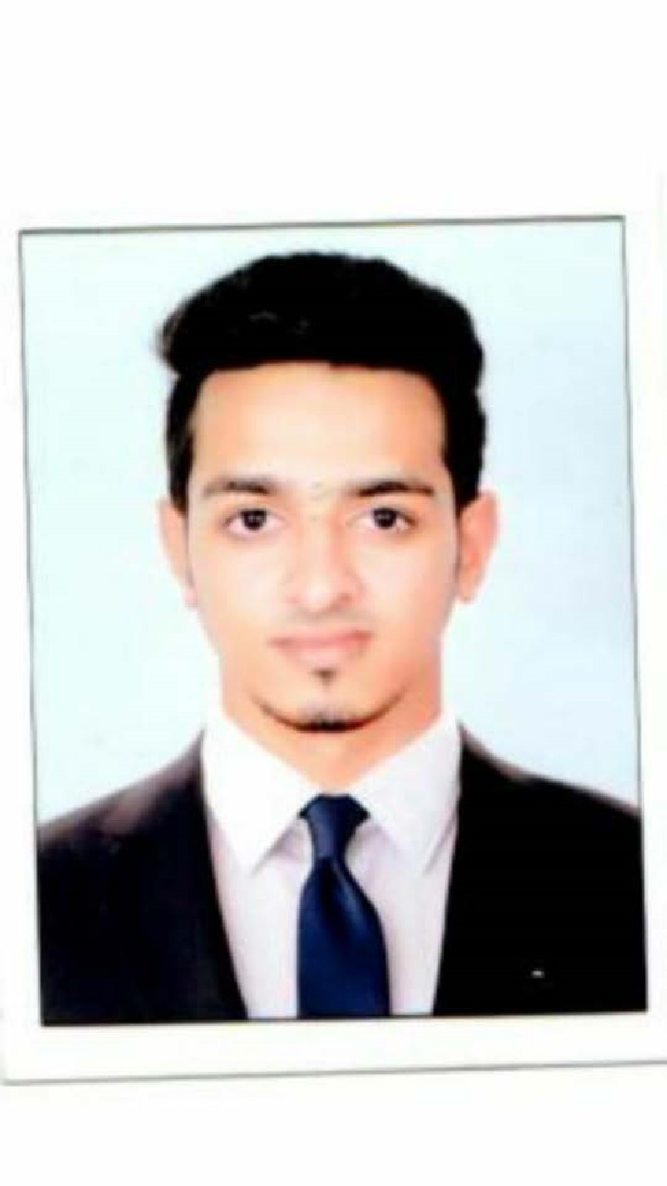  Personal Information:  Date of Birth : 14nd Feb 1993  Gender : Male  Nationality : Indian  Marital Status: Single.  Languages : English  Malayalam,  Tamil and  Arabic(R/W)  Driving License: India. | Career Objective  I am a competent professional seeking a challenging opportunity in the field of Accounts/Finance/Auditing, with a reputed and professional organization where I can contribute my skills and knowledge for the development of the organization and to build my career  Current position : Accounts/Finance/Auditing  One year of experience as Accountant  Employment History  NIZAR HOSPITAL Pvt. Ltd, India, Sept - 2015 to Oct - 2016.  Designations: ACCOUNTANT  scope of work  Accountant:  - Management of the organization’s cash flow and ensuring there are enough funds available to meet the day-to-day payments.  - All the day-to-day transactional accounting for the business.  - Work with managers to prepare the organization’s budgets and forecasts.  - Provide information to assist managers in making key strategic decisions, such as which markets or projects to pursue or the payback periods for large capital purchases.  - Manage the Finance and established appropriate internal controls  PROFESSIONAL STRENGTHS  Comprehensive problem solving abilities, positive thinking, innovative, self-motivated, multi-tasking and good natured personality. Can easily adapt to different working environments and ability to work under pressure. Proficient in Business and formal communication, both in oral and written.  CORE COMPETENCIES-  - Technical accounting skills  - Research and financial analysis abilities  - In-depth management reporting  - Developing and implementing financial systems and controls  - Budgeting and forecasting  - Facilitation of internal and external auditing procedures  - Regulatory compliance  - Staff management and development  - Knowledge of accounting regulations and standards  - Knowledge of accounting ratios

:  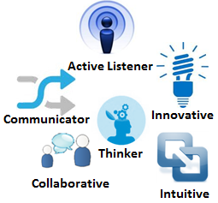 | Academic Qualifications  COURSE MAJOR BOARD/UNIVERSITY YEAR  CA-IPCC Finance ICAI Pursuing  B.Com Finance Calicut University 2016  DPA Finance ECIT 2016  CPT Finance ICAI 2014  PLUS 2 Commerce CBSE 2011  10th CBSE 2009  ACHIEVEMENTS.  - Selected as Best outgoing student of commerce department.  - ‘Kalaprathibha’ of college Arts fest.  - 200 meter champion at all Kerala state MES athletic meet in 2011.  - House captain during higher secondary at school in 2009-2011.  - College Football Team captain  TECHNICAL SKILl  Operating Systems : Windows 7, 8,10  Applications : Office Software, Photoshop  Accounting Packages: Tally, Peachtree & QuickBooks  MAJOR PROJECTS  - B.Com Major Project: Service quality and Customer Satisfaction of Nakshatra Regency Pattambi.  TRAININGS ATTENDED  - Attended in National seminar conducted by Commerce Department of MES Keveeyam college, Valanchery.  - Participated in ‘Management Training conducted by JCI’ held at MES Keveeyam college.  DECLERATION  I solemnly declare that the above details are valid and true to the best of my knowledge.

