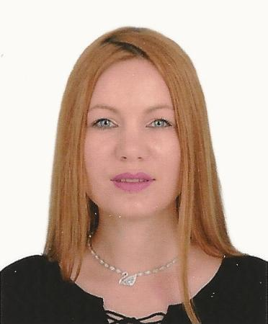
RETAIL MANAGER

VALENTINA
VALENTINA.362304@2freemail.com

A results driven professional with over 13 years experience in fashion and retail industry, I’m able to drive the sales growth and to maximize profitability by developing a friendly, well trained sales team who are always highly visible to customers and responsive to their needs. Being focused on customer service and by an efficient interpersonal communication which offer me a hands-on style of management and the ability of leading by example , I’m currently looking for a managerial position with an exciting and ambitious company

SUMMARY OF EXPERTISE

- Customer Service Focus

- Sales and Store Management

- Action plan design and implementation

- Brand Analysis

- Creating Brand Awareness

- Stock and inventory management

- Driving profitability

- Training and motivational activities

- Monitoring competition

- Business planning and reporting

WORK EXPERIENCE

Retail Manager – ZARA

Azadea Group
September 2006 – January 2017

- Achievement of Sales objectives and Shop KPI

- Reporting by collecting, analyzing, and summarizing information

- Maintenance of inventory by checking merchandise to determine inventory levels; anticipating customer demand
- Training the store staff by reviewing and revising orientation to products and sales training materials; delivering training sessions; reviewing staff job results and learning needs with retail store manager; developing and implementing new product training.

- Competition evaluation by visiting competing stores; gathering information such as style, quality, and prices of competitive merchandise.
- Purchasing inventory by researching emerging products; anticipating buyer interest; negotiating volumes; placing and expediting orders.

- Maintenance of the stability and reputation of the Brand by complying with the corporate identity and the legal requirements.
- Maintaining quality service by establishing and enforcing organization standards.

Retail Sales executive

SC Global NET SA
August 2003 – August 2005

- Responsible for new sales in the assigned territory, against a fixed quota via prospecting, qualifying and deal closing

- Management of client relationship through all phases of the sales cycle.

- Providing consultative solutions sales process to prospects.

- Development and maintenance of prospect and customer list in the CRM system.

2017

- Gathering competitive & market intelligence information.

- Supervising subordinate personnel including: hiring, determining workload and delegating assignments, training, monitoring and evaluating performance, and initiating corrective or disciplinary actions.

- Establishing sales goals for the team, with specific personal goals, encouraging multiple selling and reviewing incentive updates.
- Plan, organize, and direct overall workplace functions; coordinate time, vacation schedules and staff coverage; establish workplace procedures; authorize billings/expenditures; maintain records.
- Providing and demonstrating selling and marketing techniques.

- Coordination and liaising between agency or work unit and other agencies, work units, organizations, suppliers, etc.
- Inventory processing.

Laboratory Chemist

CELCO SA

October 1998 – March 2003

- Completing hands-on application work on technical service projects for existing products and new products entering the commercialization phase.

- Conducting, under guidance technical comparison, of the products vs. competitive products in industry specific application tests and provides the respective results/analyses/path forward.
- Complete technical application tests of products for troubleshooting to derive product recommendations and/or formulation recommendations by using multiple product lines of the portfolio and for support of growth opportunities and recommendation of next steps.
- Performing of technical testing and assessment of individual products via application testing and other analysis, providing others with respective results/analyses and recommendation of next steps.

- Ensuring and working in compliance with EH&S and ISO standards.

EDUCATION

Bachelor in science - Chemistry [2000 – 2004]

Faculty of Applied Sciences and Engineering, University “Ovidius” of Constanta, Romania

COURSES AND TRAININGS

Management development program (March – April 2015)

Conducted by Azadea Group

COMPUTER SKILLS

MS Office Suite (Word , Excel, PowerPoint, Outlook)

NAVISION

FOREIGN LANGUAGES

Romanian: Native (reading, speaking, writing)

English: Professional level (reading, speaking, writing)

Italian: Basic (reading, speaking, writing)

REFERENCES

Available on request

2017

