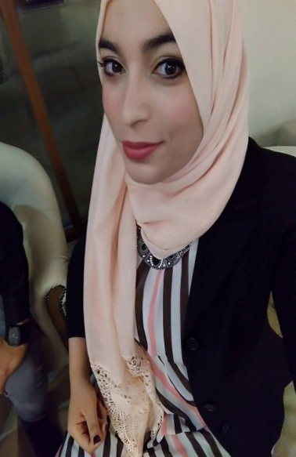
Oumayma
Oumayma.362317@2freemail.com

Objective:
To become more expert in my profession . To be able to find good and stable job that can be my stepping stone to reach all my dreams and inspiration in life. To be able to share my skills and ability in a respected institution like yours.

Job description :
- Ability to communicate important information to the mother about childcare.
- Wide knowledge of the medical terminology about Labor and Delivery.
- Extended ability to interpret normal vs abnormal findings.
- Excellent ability to perform screening and check-ups during pregnancy.
- Monitoring pregnant mother in labor, using CTG Machine and Doppler
- Profound ability to operate and interpret readings from fetal monitoring equipment.
- Giving proper medication at due times, IV and Oral Meds.
- Performing IV insertion, Skin testing and etc.
- Performing insertion of catheter,suctioning and enema aseptically.
- Carried out doctor’s order promptly.
- Perform vaginal examination.
- Profound ability to deliver non complicated cases, expulsion of the placenta and good repair of the episiotomy even extended tear.
- Giving health teaching to the mother after delivery.
- Responsible to keep area around patient clean and tidy at all time.
- Receive ful endorsement/ handover about the patient to next shift.

Training :
*- During my studies : there’s an obligatory training in the Government Hospitals 1- FARHAT HACHAD SOUSSE , 2-TAHAR SFAR MAHDIA, 3-AL OMRANE MATRENITY MONASTIR with the assist of our supervisors for 3 years of studies while every student of midwifery, to get her diploma, should deliver minimum 50 patient with placenta expulsion and viginal repair ,,
*- During summer vacation in my 3 years of studies:
-From 01/07/2014 to 31/08/2014 : volentir training in delivery room, Universal Hospital TAHAR SFAR, MAHDIA, Tunisia.
-From 01/06/2015 to 31/08/2015 : volentir training in delivery room, Universal Hospital TAHAR SFAR, MAHDIA, Tunisia.

Work experience:
*- Since 27/07/2016 until now : STAFF MIDWIFE in POLYCLINIQUE L’EXCELLENCE, MAHDIA, TUNISIA.
*- From 20/05/2016 to 26/07/2016 : STAFF MIDWIFE in UNIVERSAL HOSPITAL TAHAR SFAR , MAHDIA, TUNISIA.

Education :
*- From 2013 to 2016 : MIDWIFERY DIPLOMA in ESSTS. MONASTIR.TUNISIA.
*- From 2008 to 2011 : HIGHT SCHOOL DIPLOMA ( scientifique branche )

Personal Data :
*- Birthdate /place : 13/03/1993 in MAHDIA ,TUNISIA.
*-Civil Status : SINGLE
*- Religion : Muslim.
*- Nationality : TUNISIAN .
*- Language spoken : ARABIC, ENGLISH , FRENSH, GERMAN

OTHER TRAINING

*- Sousse 17/18 decembre 2015 : Medical day ^Adrenal insufficiency and pregnancy ^
*- Tunisian Association of Midwives Monastir regional office :
26-11-2015: Management of anemia during pregnancy
17-12-2015: The techniques of listening to the woman victim of violence
16-04 -2016: Behavior in front of an abnormal vaginal cervical smear
26-04-2016: feeding and pregnancy
*- Tunisian Association of Midwives Sousse regional office :
27-02-2016: Novelty of obstetrics
01-04-2017: maternal mortality
*- 11-07-2016 to 23-07-2016 : Preparation for childbirth without pain

