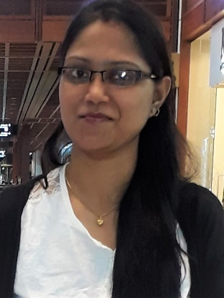
Romi

Romi.362322@2freemail.com

Objectives

Seeking the position of an Hindi Teacher in an organization that will give me an opportunity to pass on my knowledge to the students in a an innovative manner.

Personal Information

Nationality: Indian

Gender: Female

Religion: Hindu

Date of Birth: october 25,10,1989

Place of Birth: Kolkata,India

Marital Status: Married

Language: English,Hindi and Bengoli

Visa Status: Visit Visa

Educational Informatio

M.A (literature,2013)
Kolkata (W.B) India

Higher Secondary Certificate ,2006

Kolkata (W.B) India

Secondary Certificate (2004)

Kolkata (W.B) India

Office Management from SKY-INFOTECH (2009)
Kolkata (W.B) India

Work experience

Date: April 1st 2011 to Jan 2nd 2013

Designation: Teacher

Report To: Principal

School: J.N.LORETO

Location: KOLKATTA INDIA

Responsibilities :
- Profound knowledge of Hindi language and ability to teach the language for all sorts of students i.e. for those who have Hindi as there first language and those who have not.
- Excellent communication and written skills as well as ability to explain the text.
- Highly skilled in using the deferent course books and material for teaching Hindi as well as having a great passion and love for Hindi language.
- Ability to dramatize Hindi stories effectively and creatively.
- Ability to plan, collect material and deliver the lessons in the class.
- Proficient at arranging the competitions and assessing the performance of the students.
- Organizing the students in the group so they can interact with each other and socialize.
- Good understanding of Hindi grammar with an ability to impart the knowledge effectively.
- Inspiring the students to learn the new things and shaping their future according to their interest.
- Ability to inspire the students for desired results in the language teaching task.
- Ability to interact with the children effectively so they can learn quickly i.e. rhyming games, storytelling, etc.

Personal Skills

- Using self-ideology for a better result in this field.
- Making use of deferent technique for attaining the goal of the organization.
- Ability to motivate the children, so that they will consider themselves a special personality.
- Ability to create an effective teaching method for the children.
- Highly skilled in using the various tools to make the teaching interesting and effective i.e. books, music and games.

Refererence: Available upon request

I hereby certify that the above mentioned information is true to the best of my knowledge.

